ASSIGNMENT 1
Part A – if-else Statements
1. Positive, Negative or Zero
Write a program to accept an integer and determine whether it is positive, negative, or zero using if-else.
#include <iostream>
using namespace std;

int main()
{
int n;

cout << "Enter an integer: ";
cin >> n;

if (n > 0)
cout << "Positive";
else if (n < 0)
cout << "Negative";
else
cout << "Zero";

return 0;
}
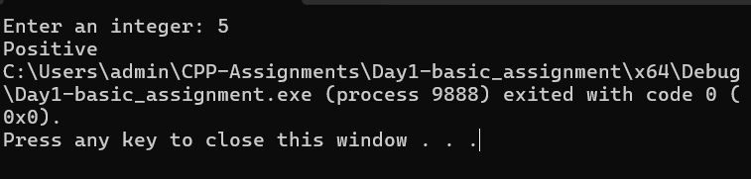

2. Even or Odd
Write a program to accept an integer and check whether the number is even or odd.
#include <iostream>
using namespace std;

int main()
{
int n;

cout << "Enter an integer: ";
cin >> n;

if (n % 2 == 0)
cout << "Even";
else
cout << "Odd";

return 0;
}
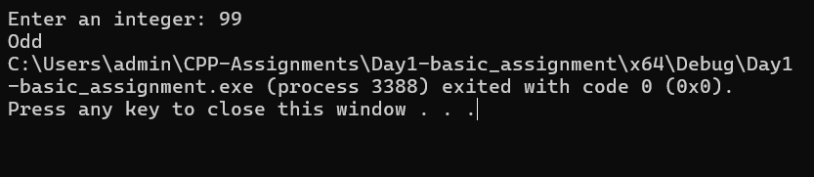

3. Largest of Two Numbers
Write a program to accept two integers and display the larger number. Also handle the case when both numbers are equal.
#include <iostream>
using namespace std;

int main()
{
int a, b;

cout << "Enter two numbers: ";
cin >> a >> b;

if (a > b)
cout << a << " is larger";
else if (b > a)
cout << b << " is larger";
else
cout << "Both numbers are equal";

return 0;
}

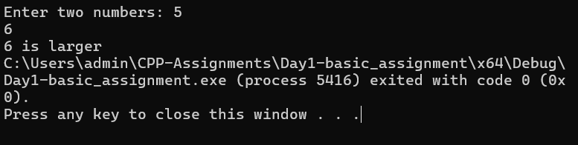

4. Largest of Three Numbers
Write a program to accept three numbers and display the largest number using if-else statements.
#include <iostream>
using namespace std;

int main()
{
int a, b, c;

cout << "Enter three numbers: ";
cin >> a >> b >> c;

if (a >= b && a >= c)
cout << a << " is largest";
else if (b >= a && b >= c)
cout << b << " is largest";
else
cout << c << " is largest";

return 0;
}

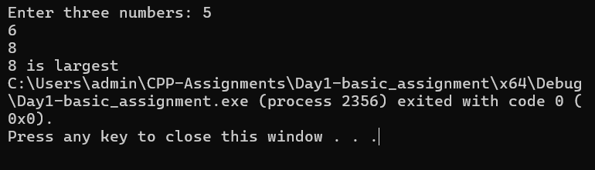
5. Grade Calculator
Accept marks obtained by a student and display the grade using the following criteria: 90–100: A, 75–89: B,
60–74: C, 40–59: D, below 40: Fail. Validate marks outside 0–100.

#include <iostream>
using namespace std;

int main()
{
int marks;

cout << "Enter marks: ";
cin >> marks;

if (marks < 0 || marks > 100)
cout << "Invalid marks";
else if (marks >= 90)
cout << "Grade A";
else if (marks >= 75)
cout << "Grade B";
else if (marks >= 60)
cout << "Grade C";
else if (marks >= 40)
cout << "Grade D";
else
cout << "Fail";

return 0;
}

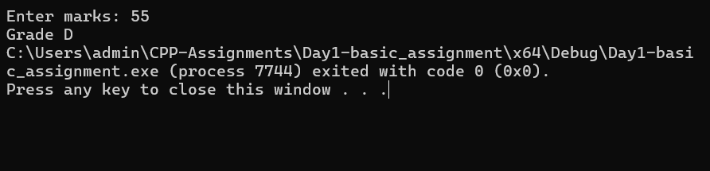
6. Leap Year
Write a program to accept a year and determine whether it is a leap year.
#include <iostream>
using namespace std;

int main()
{
int year;

cout << "Enter year: ";
cin >> year;

if ((year % 400 == 0) || (year % 4 == 0 && year % 100 != 0))
cout << "Leap Year";
else
cout << "Not a Leap Year";

return 0;
}
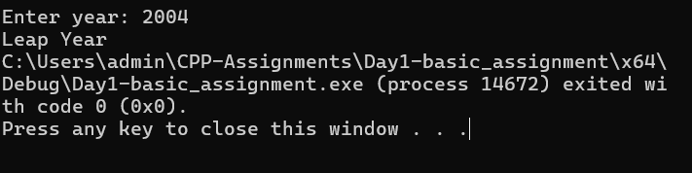
7. Simple Electricity Bill
Accept the number of electricity units consumed and calculate the bill using slab rates of your choice. Display
the total bill and explain the slabs used.
#include <iostream>
using namespace std;

int main()
{
int units;
double bill;

cout << "Enter electricity units: ";
cin >> units;

if (units < 0)
{
cout << "Invalid units";
}
else if (units <= 100)
{
bill = units * 1.50;
cout << "Bill = Rs. " << bill;
}
else if (units <= 200)
{
bill = 100 * 1.50 + (units - 100) * 2.50;
cout << "Bill = Rs. " << bill;
}
else if (units <= 300)
{
bill = 100 * 1.50 + 100 * 2.50 + (units - 200) * 4.00;
cout << "Bill = Rs. " << bill;
}
else
{
bill = 100 * 1.50 + 100 * 2.50 + 100 * 4.00
+ (units - 300) * 6.00;

cout << "Bill = Rs. " << bill;
}

return 0;
}
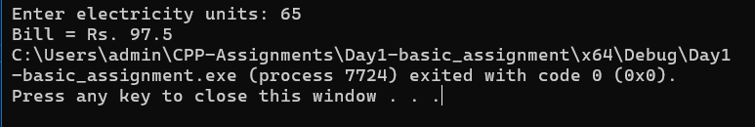
Part B – switch-case Statements
8. Simple Calculator
Create a menu-driven calculator using switch-case. The user should select addition, subtraction, multiplication,
division, or modulus and enter two numbers.
#include <iostream>
using namespace std;

int main()
{
int choice;
double a, b;

cout << "1. Addition\n";
cout << "2. Subtraction\n";
cout << "3. Multiplication\n";
cout << "4. Division\n";
cout << "5. Modulus\n";

cout << "Enter your choice: ";
cin >> choice;

cout << "Enter two numbers: ";
cin >> a >> b;

switch (choice)
{
case 1:
cout << "Result = " << a + b;
break;

case 2:
cout << "Result = " << a - b;
break;

case 3:
cout << "Result = " << a * b;
break;

case 4:
if (b != 0)
cout << "Result = " << a / b;
else
cout << "Cannot divide by zero";
break;

case 5:
cout << "Modulus requires integers";
break;

default:
cout << "Invalid choice";
}

return 0;
}
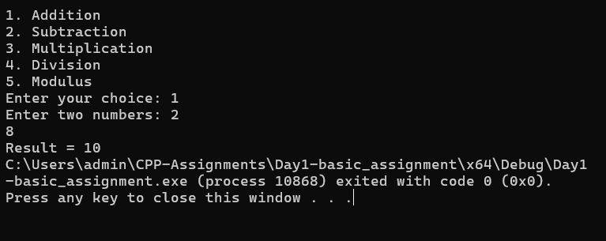

9. Month Name
Accept a number from 1 to 12 and display the corresponding month name using switch-case.
#include <iostream>
using namespace std;

int main()
{
int month;

cout << "Enter month number (1-12): ";
cin >> month;

switch (month)
{
case 1:
cout << "January";
break;

case 2:
cout << "February";
break;

case 3:
cout << "March";
break;

case 4:
cout << "April";
break;

case 5:
cout << "May";
break;

case 6:
cout << "June";
break;

case 7:
cout << "July";
break;

case 8:
cout << "August";
break;

case 9:
cout << "September";
break;

case 10:
cout << "October";
break;

case 11:
cout << "November";
break;

case 12:
cout << "December";
break;

default:
cout << "Invalid month";
}

return 0;
}

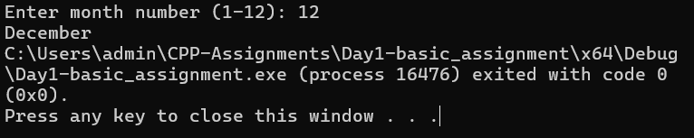

10. Vowel or Consonant
Accept a character and use switch-case to determine whether it is a vowel. If it is not a vowel, display that it is
a consonant.
#include <iostream>
using namespace std;

int main()
{
char ch;

cout << "Enter a character: ";
cin >> ch;

switch (ch)
{
case 'a':
case 'e':
case 'i':
case 'o':
case 'u':
case 'A':
case 'E':
case 'I':
case 'O':
case 'U':
cout << "Vowel";
break;

default:
cout << "Consonant";
}

return 0;
}

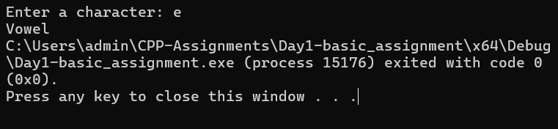
11. Menu-Driven Area Calculator
Create a menu using switch-case to calculate the area of a circle, rectangle, square, or triangle based on the user's choice.
#include <iostream>
using namespace std;

int main()
{
int choice;
double radius, length, width, side, base, height;
double area;

cout << "1. Circle\n";
cout << "2. Rectangle\n";
cout << "3. Square\n";
cout << "4. Triangle\n";

cout << "Enter your choice: ";
cin >> choice;

switch (choice)
{
case 1:
cout << "Enter radius: ";
cin >> radius;

area = 3.14159 * radius * radius;
cout << "Area of Circle = " << area;
break;

case 2:
cout << "Enter length and width: ";
cin >> length >> width;

area = length * width;
cout << "Area of Rectangle = " << area;
break;

case 3:
cout << "Enter side: ";
cin >> side;

area = side * side;
cout << "Area of Square = " << area;
break;

case 4:
cout << "Enter base and height: ";
cin >> base >> height;

area = 0.5 * base * height;
cout << "Area of Triangle = " << area;
break;

default:
cout << "Invalid choice";
}

return 0;
}

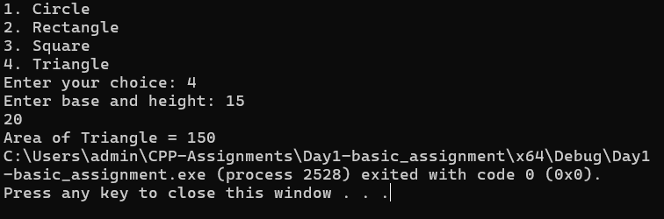

12. ATM Menu
Create a simple ATM menu using switch-case with options such as Check Balance, Deposit, Withdraw, and Exit.
Maintain the balance during the program execution.
#include <iostream>
using namespace std;

int main()
{
int choice;
double balance = 10000;
double amount;

do
{
cout << "\n\n===== ATM MENU =====";
cout << "\n1. Check Balance";
cout << "\n2. Deposit";
cout << "\n3. Withdraw";
cout << "\n4. Exit";

cout << "\nEnter choice: ";
cin >> choice;

switch (choice)
{
case 1:
cout << "Balance = Rs. " << balance;
break;

case 2:
cout << "Enter amount to deposit: ";
cin >> amount;

if (amount > 0)
{
balance += amount;
cout << "Amount deposited successfully";
}
else
cout << "Invalid amount";

break;

case 3:
cout << "Enter amount to withdraw: ";
cin >> amount;

if (amount <= 0)
cout << "Invalid amount";
else if (amount > balance)
cout << "Insufficient balance";
else
{
balance -= amount;
cout << "Amount withdrawn successfully";
}

break;

case 4:
cout << "Thank you!";
break;

default:
cout << "Invalid choice";
}

} while (choice != 4);

return 0;
}

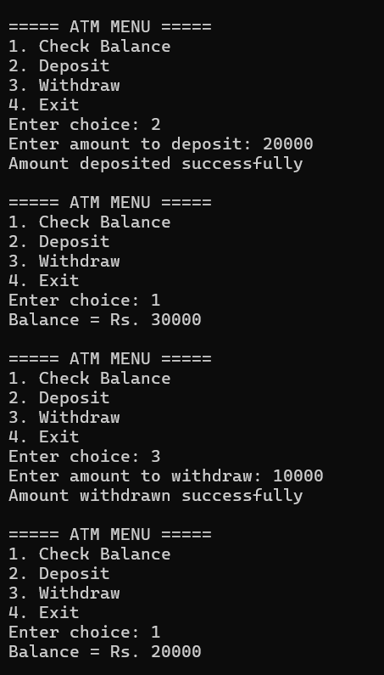

Part C – Loops (for, while and do-while)
13. Print Numbers
Write programs using for, while, and do-while loops to print numbers from 1 to N.
#include <iostream>
using namespace std;

int main()
{
int n;

cout << "Enter N: ";
cin >> n;

for (int i = 1; i <= n; i++)
cout << i << " ";

return 0;
}

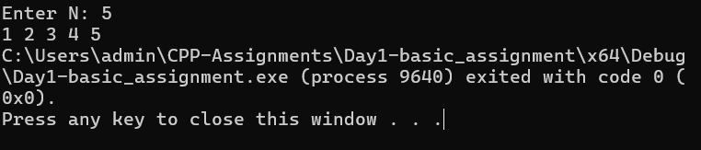

#include <iostream>
using namespace std;

int main()
{
int n, i = 1;

cout << "Enter N: ";
cin >> n;

while (i <= n)
{
cout << i << " ";
i++;
}

return 0;
}
#include <iostream>
using namespace std;

int main()
{
int n, i = 1;

cout << "Enter N: ";
cin >> n;

if (n >= 1)
{
do
{
cout << i << " ";
i++;
} while (i <= n);
}

return 0;
}

14. Sum of Natural Numbers
Accept N and calculate the sum of the first N natural numbers using a loop.
#include <iostream>
using namespace std;

int main()
{
int n;
int sum = 0;

cout << "Enter N: ";
cin >> n;

for (int i = 1; i <= n; i++)
sum += i;

cout << "Sum = " << sum;

return 0;
}

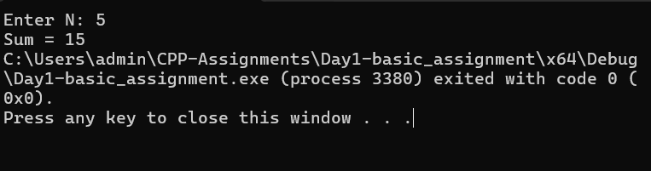
15. Multiplication Table
Accept a number and print its multiplication table from 1 to 10 using a loop.
#include <iostream>
using namespace std;

int main()
{
int n;

cout << "Enter number: ";
cin >> n;

for (int i = 1; i <= 10; i++)
cout << n << " x " << i << " = " << n * i << endl;

return 0;
}

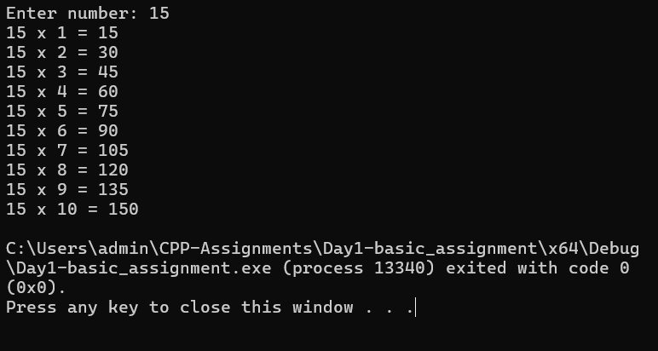
16. Factorial
Accept a positive integer and calculate its factorial using a loop.
#include <iostream>
using namespace std;

int main()
{
int n;
long long factorial = 1;

cout << "Enter a positive integer: ";
cin >> n;

if (n < 0)
{
cout << "Invalid input";
}
else
{
for (int i = 1; i <= n; i++)
factorial *= i;

cout << "Factorial = " << factorial;
}

return 0;
}
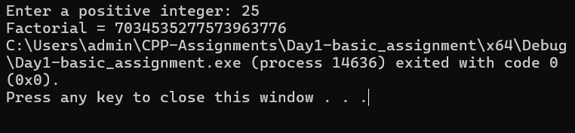
17. Reverse a Number
Accept an integer and reverse its digits using a while loop.
#include <iostream>
using namespace std;

int main()
{
int n, reverse = 0, digit;

cout << "Enter number: ";
cin >> n;

while (n != 0)
{
digit = n % 10;
reverse = reverse * 10 + digit;
n = n / 10;
}

cout << "Reverse = " << reverse;

return 0;
}
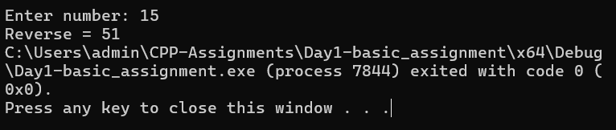
18. Palindrome Number
Accept an integer and determine whether it is a palindrome number.
#include <iostream>
using namespace std;

int main()
{
int n, original, reverse = 0, digit;

cout << "Enter number: ";
cin >> n;

original = n;

while (n != 0)
{
digit = n % 10;
reverse = reverse * 10 + digit;
n = n / 10;
}

if (original == reverse)
cout << "Palindrome Number";
else
cout << "Not a Palindrome Number";

return 0;
}
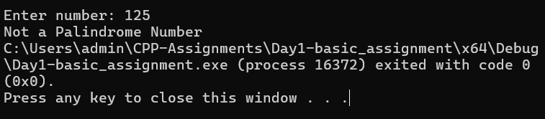

19. Count Digits
Accept an integer and count the number of digits using a loop.
#include <iostream>
using namespace std;

int main()
{
int n, count = 0;

cout << "Enter number: ";
cin >> n;

if (n == 0)
{
count = 1;
}
else
{
if (n < 0)
n = -n;

while (n != 0)
{
n = n / 10;
count++;
}
}

cout << "Number of digits = " << count;

return 0;
}

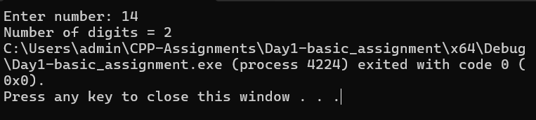
20. Sum of Digits
Accept an integer and calculate the sum of all its digits.
#include <iostream>
using namespace std;

int main()
{
int n, digit, sum = 0;

cout << "Enter number: ";
cin >> n;

if (n < 0)
n = -n;

while (n != 0)
{
digit = n % 10;
sum += digit;
n = n / 10;
}

cout << "Sum of digits = " << sum;

return 0;
}

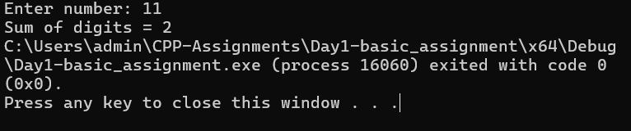
21. Prime Number
Accept an integer and determine whether it is a prime number using a loop.
#include <iostream>
using namespace std;

int main()
{
int n;
bool prime = true;

cout << "Enter number: ";
cin >> n;

if (n <= 1)
{
prime = false;
}
else
{
for (int i = 2; i <= n / 2; i++)
{
if (n % i == 0)
{
prime = false;
break;
}
}
}

if (prime)
cout << "Prime Number";
else
cout << "Not a Prime Number";

return 0;
}

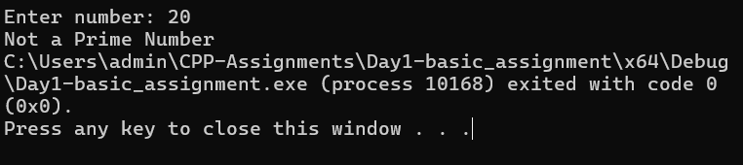

Assignment-2

PART A: Pass by Address and Reference

1. Write a function that accepts the addresses of two integers and swaps their values using pointers.
CODE:
#include <iostream>
using namespace std;
void swapValues(int* a, int* b)
{
int temp = *a;
*a = *b;
*b = temp;
}

int main()
{
int x = 10, y = 20;

cout << "Before swapping: x = " << x << ", y = " << y << endl;

swapValues(&x, &y);

cout << "After swapping: x = " << x << ", y = " << y << endl;

return 0;
}
OUTPUT:

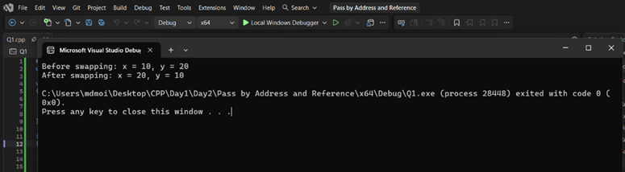

2. Write a function that accepts two integers using pass by reference and swaps their values.
CODE:
#include <iostream>
using namespace std;
void swapValues(int& a, int& b)
{
int temp = a;
a = b;
b = temp;
}
int main()
{
int x = 10, y = 20;
cout << "Before swapping: x = " << x << ", y = " << y << endl;
swapValues(x, y);
cout << "After swapping: x = " << x << ", y = " << y << endl;
return 0;
}
OUTPUT:
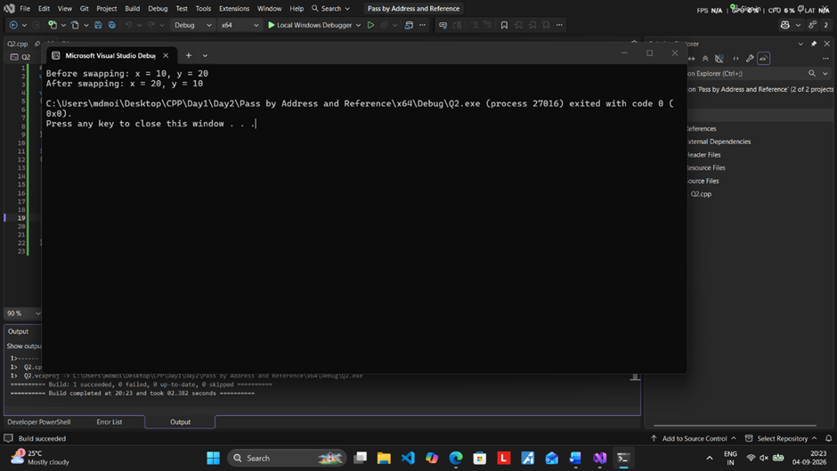

3. Write a function using pass by reference to calculate the sum and difference of two numbers and return both results through reference parameters.
CODE:
#include <iostream>
using namespace std;
void calculate(int a, int b, int& sum, int& difference)
{
sum = a + b;
difference = a - b;
}
int main()
{
int a = 20, b = 10;
int sum, difference;
calculate(a, b, sum, difference);
cout << "Sum = " << sum << endl;
cout << "Difference = " << difference << endl;
return 0;
}

OUTPUT:
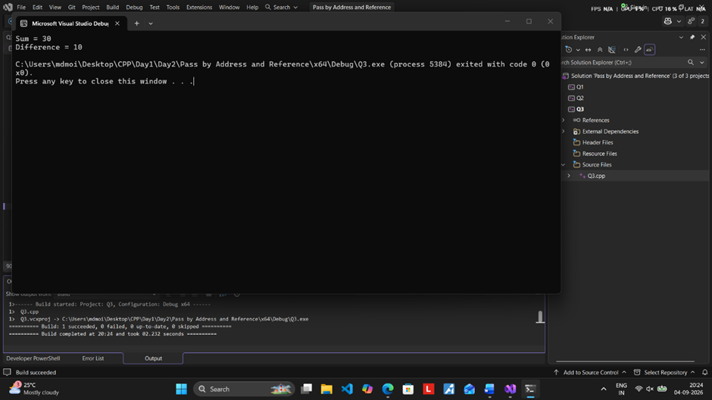

4. Write a function using pass by reference to reverse the digits of a number and update the original variable in main.
CODE:
#include <iostream>
using namespace std;

void reverseNumber(int& num)
{
int reversed = 0;
int digit;

while (num != 0)
{
digit = num % 10;
reversed = reversed * 10 + digit;
num = num / 10;
}

num = reversed;
}

int main()
{
int num = 12345;

cout << "Before reversing: " << num << endl;

reverseNumber(num);

cout << "After reversing: " << num << endl;

return 0;
}

OUTPUT:

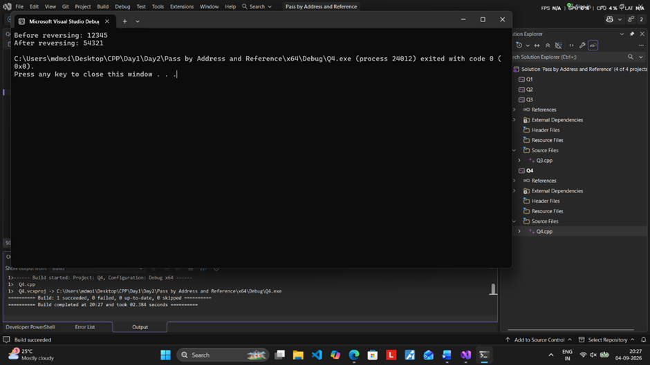

PART B: Dynamic Memory Allocation – Arrays

1. Write a menu-driven C++ program to dynamically allocate an integer array of N elements and perform
the following operations using user-defined functions:
1. Accept and display the array elements.
2. Find and display the largest and smallest elements.
3. Calculate and display the sum and average of the array elements.
4. Count and display the number of even and odd elements.
5. Search for a given element using linear search.
6. Exit the program.
CODE:
#include <iostream>
using namespace std;

// Function to accept array elements
void acceptArray(int* arr, int n)
{
cout << "Enter " << n << " elements:\n";
for (int i = 0; i < n; i++)
{
cin >> arr[i];
}
}

// Function to display array elements
void displayArray(int* arr, int n)
{
cout << "Array elements: ";
for (int i = 0; i < n; i++)
{
cout << arr[i] << " ";
}
cout << endl;
}

// Function to find largest and smallest
void findLargestSmallest(int* arr, int n)
{
int largest = arr[0];
int smallest = arr[0];

for (int i = 1; i < n; i++)
{
if (arr[i] > largest)
largest = arr[i];

if (arr[i] < smallest)
smallest = arr[i];
}

cout << "Largest element = " << largest << endl;
cout << "Smallest element = " << smallest << endl;
}

// Function to calculate sum and average
void calculateSumAverage(int* arr, int n)
{
int sum = 0;

for (int i = 0; i < n; i++)
{
sum += arr[i];
}

double average = (double)sum / n;
cout << "Sum = " << sum << endl;
cout << "Average = " << average << endl;
}
// Function to count even and odd elements
void countEvenOdd(int* arr, int n)
{
int even = 0, odd = 0;
for (int i = 0; i < n; i++)
{
if (arr[i] % 2 == 0)
even++;
else
odd++;
}
cout << "Number of even elements = " << even << endl;
cout << "Number of odd elements = " << odd << endl;
}
// Function for linear search
void linearSearch(int* arr, int n)
{
int key;
cout << "Enter element to search: ";
cin >> key;
for (int i = 0; i < n; i++)
{
if (arr[i] == key)
{
cout << "Element found at position " << i + 1 << endl;
return;
}
}
cout << "Element not found." << endl;
}
int main()
{
int n, choice;
cout << "Enter number of elements (N): ";
cin >> n;

// Dynamic memory allocation
int* arr = new int[n];

do
{
cout << "\n========== MENU ==========\n";
cout << "1. Accept and display array elements\n";
cout << "2. Find largest and smallest elements\n";
cout << "3. Calculate sum and average\n";
cout << "4. Count even and odd elements\n";
cout << "5. Search an element using linear search\n";
cout << "6. Exit\n";
cout << "==========================\n";
cout << "Enter your choice: ";
cin >> choice;

switch (choice)
{
case 1:
acceptArray(arr, n);
displayArray(arr, n);
break;
case 2:
findLargestSmallest(arr, n);
break;
case 3:
calculateSumAverage(arr, n);
break;
case 4:
countEvenOdd(arr, n);
break;
case 5:
linearSearch(arr, n);
break;
case 6:
cout << "Exiting program..." << endl;
break;
default:
cout << "Invalid choice! Please try again." << endl;
}
} while (choice != 6);
// Free dynamically allocated memory
delete[] arr;

return 0;}

OUTPUT:
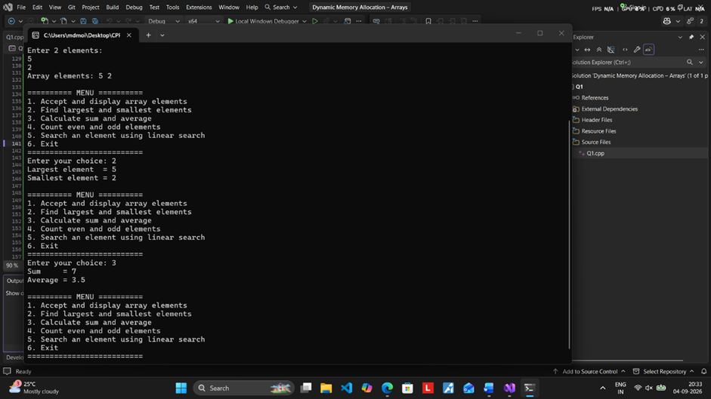
2. Write a menu-driven C++ program to dynamically allocate memory for the prices of N products in a
store and perform the following operations using user-defined functions:
1. Accept and display the product prices.
2. Find and display the highest and lowest-priced products.
3. Calculate and display the total inventory value and average product price.
4. Count the number of products whose price is above and below the average price.
5. Search for a particular product price using linear search.
6. Apply a given discount percentage to all product prices and display the updated prices.
7. Exit the program
CODE:
#include <iostream>
#include <iomanip>
using namespace std;

// Function to accept product prices
void acceptPrices(double* price, int n)
{
cout << "Enter prices of " << n << " products:\n";

for (int i = 0; i < n; i++)
{
cout << "Product " << i + 1 << ": ";
cin >> price[i];
}
}

// Function to display product prices
void displayPrices(double* price, int n)
{
cout << "\nProduct Prices:\n";

for (int i = 0; i < n; i++)
{
cout << "Product " << i + 1 << ": Rs. "
<< fixed << setprecision(2) << price[i] << endl;
}
}

// Function to find highest and lowest prices
void findHighestLowest(double* price, int n)
{
double highest = price[0];
double lowest = price[0];
int highestProduct = 0;
int lowestProduct = 0;

for (int i = 1; i < n; i++)
{
if (price[i] > highest)
{
highest = price[i];
highestProduct = i;
}

if (price[i] < lowest)
{
lowest = price[i];
lowestProduct = i;
}
}

cout << "\nHighest-priced product: Product "
<< highestProduct + 1 << " = Rs. "
<< fixed << setprecision(2) << highest << endl;

cout << "Lowest-priced product: Product "
<< lowestProduct + 1 << " = Rs. "
<< fixed << setprecision(2) << lowest << endl;
}

// Function to calculate total inventory value and average price
double calculateAverage(double* price, int n)
{
double total = 0;

for (int i = 0; i < n; i++)
{
total += price[i];
}

double average = total / n;

cout << "\nTotal Inventory Value = Rs. "
<< fixed << setprecision(2) << total << endl;

cout << "Average Product Price = Rs. "
<< fixed << setprecision(2) << average << endl;

return average;
}

// Function to count products above and below average
void countAboveBelowAverage(double* price, int n)
{
double total = 0;

for (int i = 0; i < n; i++)
{
total += price[i];
}

double average = total / n;

int above = 0;
int below = 0;

for (int i = 0; i < n; i++)
{
if (price[i] > average)
above++;
else if (price[i] < average)
below++;
}

cout << "\nAverage Price = Rs. "
<< fixed << setprecision(2) << average << endl;

cout << "Products above average = " << above << endl;
cout << "Products below average = " << below << endl;
}

// Function for linear search
void searchPrice(double* price, int n)
{
double searchValue;

cout << "\nEnter product price to search: Rs. ";
cin >> searchValue;

bool found = false;

for (int i = 0; i < n; i++)
{
if (price[i] == searchValue)
{
cout << "Price found at Product " << i + 1 << endl;
found = true;
}
}

if (!found)
{
cout << "Product price not found." << endl;
}
}

// Function to apply discount
void applyDiscount(double* price, int n)
{
double discount;

cout << "\nEnter discount percentage: ";
cin >> discount;

if (discount < 0 || discount > 100)
{
cout << "Invalid discount percentage!" << endl;
return;
}

for (int i = 0; i < n; i++)
{
price[i] = price[i] - (price[i] * discount / 100);
}

cout << "\nPrices after " << discount << "% discount:\n";
displayPrices(price, n);
}

int main()
{
int n, choice;
cout << "Enter number of products (N): ";
cin >> n;
if (n <= 0)
{
cout << "Invalid number of products!" << endl;
return 0;
}
// Dynamically allocate memory
double* price = new double[n];
do
{
cout << "\n========== MENU ==========\n";
cout << "1. Accept and display product prices\n";
cout << "2. Find highest and lowest-priced products\n";
cout << "3. Calculate total inventory value and average price\n";
cout << "4. Count products above and below average price\n";
cout << "5. Search for a product price\n";
cout << "6. Apply discount and display updated prices\n";
cout << "7. Exit\n";
cout << "==========================\n";

cout << "Enter your choice: ";
cin >> choice;

switch (choice)
{
case 1:
acceptPrices(price, n);
displayPrices(price, n);
break;

case 2:
findHighestLowest(price, n);
break;

case 3:
calculateAverage(price, n);
break;

case 4:
countAboveBelowAverage(price, n);
break;

case 5:
searchPrice(price, n);
break;

case 6:
applyDiscount(price, n);
break;
case 7:
cout << "\nExiting program..." << endl;
break;
default:
cout << "\nInvalid choice! Please try again." << endl;
}
} while (choice != 7);
// Release dynamically allocated memory
delete[] price;
return 0;
}
OUTPUT:
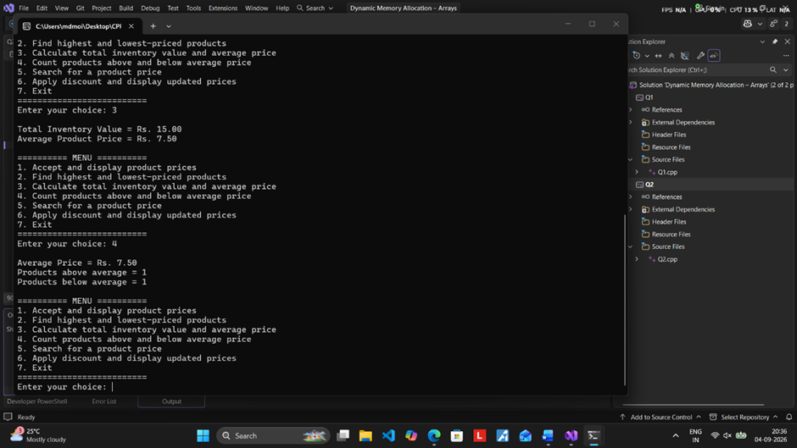

Assignment-3 (Classes and Objects)
1. Bank Account
Create a BankAccount class with account number, customer name, and balance. Use a
constructor to initialize account details. Implement member functions to deposit, withdraw,
and display the balance. Create multiple account objects using an array of objects.

BankAccount.h

#include <iostream>
#include <string>
using namespace std;

class BankAccount
{
int accountNumber;
string customerName;
double balance;

public:

BankAccount(int accNo, string name, double bal)
{
accountNumber = accNo;
customerName = name;
balance = bal;
}

int getAccountNumber()
{
return accountNumber;
}

void deposit(double amount)
{
if (amount > 0)
{
balance += amount;
cout << "Amount deposited successfully.\n";
}
else
{
cout << "Invalid amount.\n";
}
}

void withdraw(double amount)
{
if (amount <= 0)
{
cout << "Invalid amount.\n";
}
else if (amount > balance)
{
cout << "Insufficient balance.\n";
}
else
{
balance -= amount;
cout << "Amount withdrawn successfully.\n";
}
}

void display()
{
cout << "\n-------------------------";
cout << "\nAccount Number : " << accountNumber;
cout << "\nCustomer Name : " << customerName;
cout << "\nBalance : " << balance;
cout << "\n-------------------------\n";
}
};

Client.cpp
#include "Header.h"

int main()
{
int n;

cout << "Enter number of accounts (1 to 5): ";
cin >> n;

while (n < 1 || n > 5)
{
cout << "Please enter number between 1 and 5: ";
cin >> n;
}

BankAccount* accounts[5];

// Create accounts
for (int i = 0; i < n; i++)
{
int accNo;
string name;
double balance;

cout << "\n===== Account " << i + 1 << " =====\n";

cout << "Enter Account Number: ";
cin >> accNo;

cin.ignore();

cout << "Enter Customer Name: ";
getline(cin, name);

cout << "Enter Initial Balance: ";
cin >> balance;

accounts[i] = new BankAccount(accNo, name, balance);
}

int choice;

do
{
cout << "\n\n========== BANK MENU ==========";
cout << "\n1. Deposit";
cout << "\n2. Withdraw";
cout << "\n3. Display All Accounts";
cout << "\n4. Exit";
cout << "\n================================";
cout << "\nEnter your choice: ";
cin >> choice;

switch (choice)
{
case 1:
{
int accNo;
double amount;
bool found = false;

cout << "\nEnter Account Number: ";
cin >> accNo;

for (int i = 0; i < n; i++)
{
if (accounts[i]->getAccountNumber() == accNo)
{
cout << "Enter amount to deposit: ";
cin >> amount;

accounts[i]->deposit(amount);
found = true;
break;
}
}

if (!found)
{
cout << "Account not found.\n";
}

break;
}

case 2:
{
int accNo;
double amount;
bool found = false;

cout << "\nEnter Account Number: ";
cin >> accNo;

for (int i = 0; i < n; i++)
{
if (accounts[i]->getAccountNumber() == accNo)
{
cout << "Enter amount to withdraw: ";
cin >> amount;

accounts[i]->withdraw(amount);
found = true;
break;
}
}

if (!found)
{
cout << "Account not found.\n";
}

break;
}

case 3:
{
cout << "\n===== ALL ACCOUNT DETAILS =====\n";

for (int i = 0; i < n; i++)
{
accounts[i]->display();
}

break;
}

case 4:
cout << "\nThank you! Exiting program...\n";
break;

default:
cout << "\nInvalid choice. Please try again.\n";
}

} while (choice != 4);

// Delete dynamically created objects
for (int i = 0; i < n; i++)
{
delete accounts[i];
}

return 0;
}
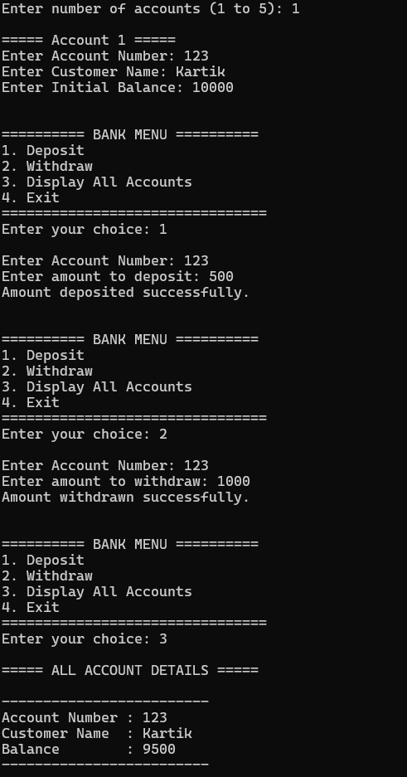

2. Book Management
Create a Book class with book ID, title, author, and price. Use a constructor to initialize the
data members. Store details of multiple books in an array of objects and search for a book
using its ID.
Book.h
#pragma once
#include <string>
using namespace std;

class Book
{
private:
int bookID;
string title;
string author;
float price;

public:
Book();
Book(int id, string t, string a, float p);

void display();
int getBookID();
};

Client.cpp
#include <iostream>
#include "Book.h"
using namespace std;

// Default constructor
Book::Book()
{
bookID = 0;
title = "";
author = "";
price = 0;
}

// Parameterized constructor
Book::Book(int id, string t, string a, float p)
{
bookID = id;
title = t;
author = a;
price = p;
}

// Display book details
void Book::display()
{
cout << "\nBook ID : " << bookID;
cout << "\nTitle : " << title;
cout << "\nAuthor : " << author;
cout << "\nPrice : " << price << endl;
}

// Return Book ID
int Book::getBookID()
{
return bookID;
}

// Main function
int main()
{
int n;

cout << "Enter number of books: ";
cin >> n;

Book books[100];

// Input details
for (int i = 0; i < n; i++)
{
int id;
string title, author;
float price;

cout << "\nEnter details of Book " << i + 1 << endl;

cout << "Book ID: ";
cin >> id;

cin.ignore();

cout << "Title: ";
getline(cin, title);

cout << "Author: ";
getline(cin, author);

cout << "Price: ";
cin >> price;

books[i] = Book(id, title, author, price);
}

// Search
int searchID;
cout << "\nEnter Book ID to search: ";
cin >> searchID;

bool found = false;

for (int i = 0; i < n; i++)
{
if (books[i].getBookID() == searchID)
{
cout << "\nBook Found!";
books[i].display();
found = true;
break;
}
}

if (!found)
{
cout << "\nBook not found.";
}

return 0;
}

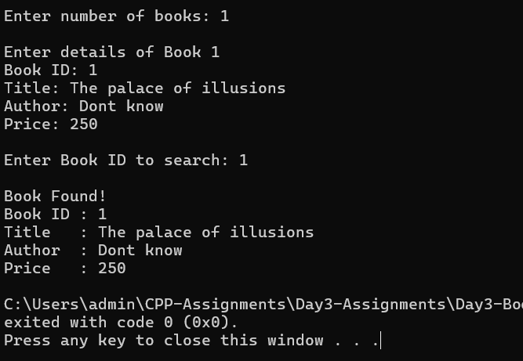

3. Vehicle Registration System
Create a Vehicle class with registration number, owner name, and vehicle type. Use
constructors to initialize objects. Maintain a static member to count the total number of
registered vehicles. Store multiple vehicles in an array of objects and display all records.

Header.h
#pragma once
#include <iostream>
#include <string>
using namespace std;

class Vehicle
{
private:
int registrationNumber;
string ownerName;
string vehicleType;

static int totalVehicles;

public:
Vehicle();
Vehicle(int regNo, string owner, string type);

void accept();
void display();

static int getTotalVehicles();
};

Source.cpp
#include "Header.h"

int Vehicle::totalVehicles = 0;

// Default constructor
Vehicle::Vehicle()
{
registrationNumber = 0;
ownerName = "";
vehicleType = "";
}

// Parameterized constructor
Vehicle::Vehicle(int regNo, string owner, string type)
{
registrationNumber = regNo;
ownerName = owner;
vehicleType = type;

totalVehicles++;
}

// Accept vehicle details
void Vehicle::accept()
{
cout << "Enter Registration Number: ";
cin >> registrationNumber;

cout << "Enter Owner Name: ";
cin >> ownerName;

cout << "Enter Vehicle Type: ";
cin >> vehicleType;

totalVehicles++;
}

// Display vehicle details
void Vehicle::display()
{
cout << "Registration Number : " << registrationNumber << endl;
cout << "Owner Name : " << ownerName << endl;
cout << "Vehicle Type : " << vehicleType << endl;
}

// Static function
int Vehicle::getTotalVehicles()
{
return totalVehicles;
}

int main()
{
int n;

cout << "Enter number of vehicles: ";
cin >> n;

Vehicle vehicles[100];

for (int i = 0; i < n; i++)
{
cout << "\nEnter details of Vehicle " << i + 1 << endl;
vehicles[i].accept();
}

cout << "\n===== Vehicle Records =====\n";

for (int i = 0; i < n; i++)
{
cout << "\nVehicle " << i + 1 << endl;
vehicles[i].display();
}

cout << "\nTotal Registered Vehicles: "
<< Vehicle::getTotalVehicles() << endl;

return 0;
}

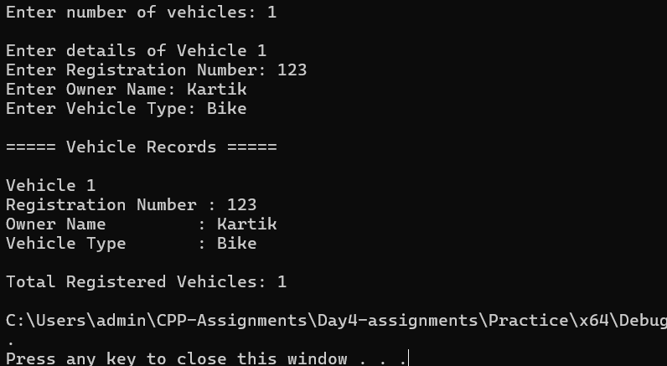
4. Library Fine Calculator
Create a LibraryMember class with member ID, name, and number of overdue days. Use a
constructor to initialize the data. Write a member function to calculate the fine. Use a static
data member to store the fine rate per day and a static member function to modify or
display the fine rate.
Header.h
#pragma once
#include <iostream>
#include <string>
using namespace std;

class LibraryMember
{
private:
int memberID;
string name;
int overdueDays;

static float fineRate;

public:
LibraryMember(); // Default constructor

LibraryMember(int id, string n, int days); // Parameterized constructor

float calculateFine();

static void setFineRate(float rate);
static float getFineRate();

void display();
};

Source.cpp
#include "Header.h"

float LibraryMember::fineRate = 5.0;

// Default constructor
LibraryMember::LibraryMember()
{
memberID = 0;
name = "";
overdueDays = 0;
}

// Parameterized constructor
LibraryMember::LibraryMember(int id, string n, int days)
{
memberID = id;
name = n;
overdueDays = days;
}

// Calculate fine
float LibraryMember::calculateFine()
{
return overdueDays * fineRate;
}

// Modify fine rate
void LibraryMember::setFineRate(float rate)
{
fineRate = rate;
}

// Display fine rate
float LibraryMember::getFineRate()
{
return fineRate;
}

// Display details
void LibraryMember::display()
{
cout << "\nMember ID : " << memberID;
cout << "\nName : " << name;
cout << "\nOverdue Days : " << overdueDays;
cout << "\nFine Rate/Day : Rs. " << fineRate;
cout << "\nTotal Fine : Rs. " << calculateFine();
}

int main()
{
int n;

cout << "Enter number of members: ";
cin >> n;

LibraryMember members[100];

for (int i = 0; i < n; i++)
{
int id, days;
string name;

cout << "\nEnter details of member " << i + 1 << endl;

cout << "Enter Member ID: ";
cin >> id;

cout << "Enter Name: ";
cin >> name;

cout << "Enter Overdue Days: ";
cin >> days;

members[i] = LibraryMember(id, name, days);
}

cout << "\nCurrent Fine Rate: Rs. "
<< LibraryMember::getFineRate()
<< " per day";

float rate;

cout << "\n\nEnter new fine rate per day: ";
cin >> rate;

LibraryMember::setFineRate(rate);

cout << "\nUpdated Fine Rate: Rs. "
<< LibraryMember::getFineRate()
<< " per day";

cout << "\n\n===== Library Records =====\n";

for (int i = 0; i < n; i++)
{
cout << "\nMember " << i + 1;
members[i].display();
cout << "\n";
}

return 0;
}

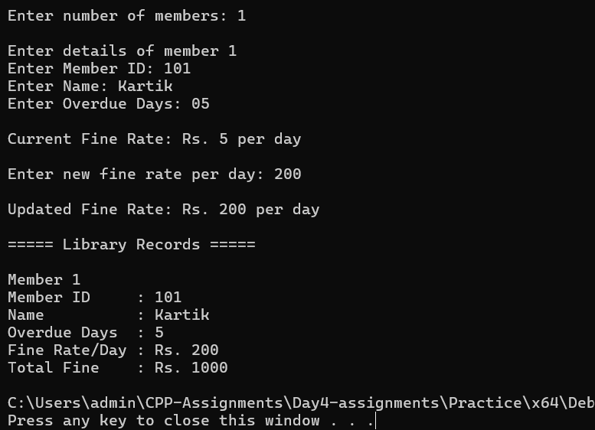

Assignment-4
1.Complex Number Addition
Header.h
#pragma once
#include <iostream>
using namespace std;

class Complex
{
private:
int real;
int imaginary;

public:

// Default Constructor
Complex()
{
real = 0;
imaginary = 0;
}

// Parameterized Constructor
Complex(int r, int i)
{
real = r;
imaginary = i;
}

// Overload + operator
Complex operator+(Complex obj)
{
Complex temp;

temp.real = real + obj.real;
temp.imaginary = imaginary + obj.imaginary;

return temp;
}

// Display function
void display()
{
if (imaginary >= 0)
cout << real << " + " << imaginary << "i";
else
cout << real << " - " << -imaginary << "i";
}
};

Source.cpp
/*1. Complex Number Addition
Create a Complex class with real and imaginary data members. Initialize the complex
numbers using appropriate constructors. Overload the '+' operator to add two Complex
objects and display the resulting complex number.*/

#include <iostream>
#include "Complex.h"

using namespace std;

int main()
{
int real1, imaginary1;
int real2, imaginary2;

cout << "Enter real part of first complex number: ";
cin >> real1;

cout << "Enter imaginary part of first complex number: ";
cin >> imaginary1;

cout << "\nEnter real part of second complex number: ";
cin >> real2;

cout << "Enter imaginary part of second complex number: ";
cin >> imaginary2;

// Create two objects using parameterized constructor
Complex c1(real1, imaginary1);
Complex c2(real2, imaginary2);

// Add two complex numbers
Complex c3 = c1 + c2;

cout << "\n\nFirst Complex Number : ";
c1.display();

cout << "\nSecond Complex Number : ";
c2.display();

cout << "\nResult of Addition : ";
c3.display();

return 0;
}

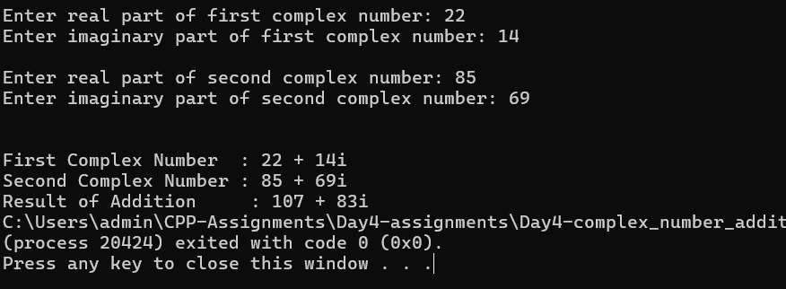

2.Distance Comparision and Addition
Source.cpp
/*2. Distance Comparison and Addition
Create a Distance class with feet and inches as data members. Use constructors to initialize
Distance objects. Overload the '+' operator to add two Distance objects and overload the '=='
operator to compare whether two Distance objects are equal. Display the appropriate
results.*/

#include <iostream>
#include "Distance.h"

using namespace std;

int main()
{
int feet1, inches1;
int feet2, inches2;

cout << "Enter feet for first distance: ";
cin >> feet1;

cout << "Enter inches for first distance: ";
cin >> inches1;

cout << "\nEnter feet for second distance: ";
cin >> feet2;

cout << "Enter inches for second distance: ";
cin >> inches2;

// Create objects using parameterized constructor
Distance d1(feet1, inches1);
Distance d2(feet2, inches2);

// Add two distances
Distance d3 = d1 + d2;

cout << "\n\nFirst Distance : ";
d1.display();

cout << "\nSecond Distance : ";
d2.display();

cout << "\n\nAddition : ";
d3.display();

// Compare two distances
if (d1 == d2)
{
cout << "\n\nBoth distances are equal.";
}
else
{
cout << "\n\nBoth distances are not equal.";
}

return 0;
}

Header.h
#pragma once
#include <iostream>
using namespace std;

class Distance
{
private:
int feet;
int inches;

public:

// Default Constructor
Distance()
{
feet = 0;
inches = 0;
}

// Parameterized Constructor
Distance(int f, int i)
{
feet = f;
inches = i;
}

// Overload + operator
Distance operator+(Distance obj)
{
Distance temp;

temp.feet = feet + obj.feet;
temp.inches = inches + obj.inches;

// Convert inches into feet
if (temp.inches >= 12)
{
temp.feet = temp.feet + (temp.inches / 12);
temp.inches = temp.inches % 12;
}

return temp;
}

// Overload == operator
bool operator==(Distance obj)
{
int totalInches1;
int totalInches2;

totalInches1 = (feet * 12) + inches;
totalInches2 = (obj.feet * 12) + obj.inches;

return totalInches1 == totalInches2;
}

// Display function
void display()
{
cout << feet << " feet " << inches << " inches";
}
};

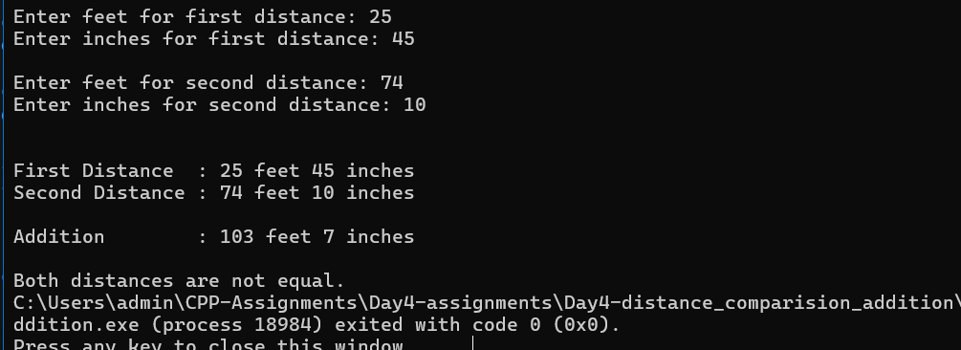

3. Dynamic Integer Storage
Source.cpp
/*1. Dynamic Integer Storage
Create a class Number that dynamically allocates memory for an integer using a pointer.
Initialize the value using a constructor, implement a copy constructor to create a deep copy,
and use a destructor to release the dynamically allocated memory.*/

#include <iostream>
#include "Number.h"

using namespace std;

int main()
{
int n;

cout << "Enter an integer: ";
cin >> n;

cout << "\n\nCreating object obj1...";
Number obj1(n);

cout << "\n\nDetails of obj1:";
obj1.display();

cout << "\n\nCreating object obj2 using copy constructor...";
Number obj2(obj1);

cout << "\n\nDetails of obj2:";
obj2.display();

cout << "\n\n\nEnd of program.";

return 0;
}

Header.h
#pragma once
#include <iostream>
using namespace std;

class Number
{
private:
int* value;

public:
// Parameterized Constructor
Number(int v)
{
value = new int;
*value = v;

cout << "\nConstructor called";
}

// Copy Constructor - Deep Copy
Number(const Number& obj)
{
value = new int;
*value = *(obj.value);

cout << "\nCopy Constructor called";
}

// Display function
void display()
{
cout << "\nValue = " << *value;
cout << "\nAddress = " << value;
}

// Destructor
~Number()
{
delete value;

cout << "\nDestructor called";
}
};

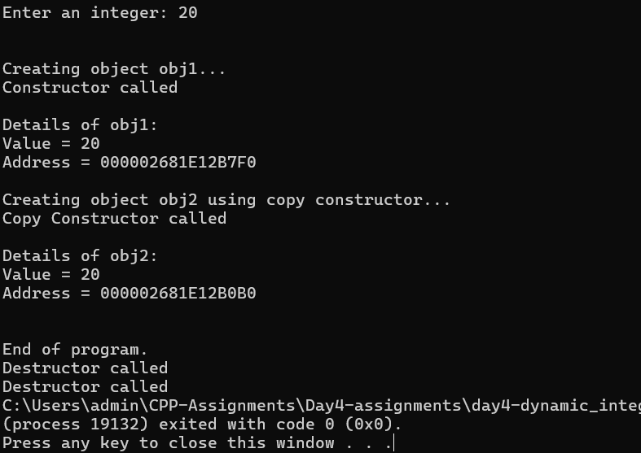

4.Library Member Records
Source.cpp
/*2. Library Member Records
Create a LibraryMember class with member ID, name, and number of books issued.
Initialize an object using a constructor and create another object using a copy constructor.
Use a destructor to display a message when a member object is removed.*/

#include <iostream>
#include <string>
#include "LibraryMember.h"

using namespace std;

int main()
{
int id;
string name;
int books;

// Accept details from user
cout << "Enter Member ID: ";
cin >> id;

cout << "Enter Member Name: ";
cin >> name;

cout << "Enter Number of Books Issued: ";
cin >> books;

// Create first object using constructor
cout << "\n\nCreating first object...";
LibraryMember obj1(id, name, books);

cout << "\n\nDetails of First Member:";
obj1.display();

// Create second object using copy constructor
cout << "\n\n\nCreating second object using copy constructor...";
LibraryMember obj2(obj1);

cout << "\n\nDetails of Second Member:";
obj2.display();

cout << "\n\n\nEnd of program.";

return 0;
}

Header.h
#pragma once
#include <iostream>
#include <string>
using namespace std;

class LibraryMember
{
private:
int memberID;
string name;
int booksIssued;
public:

// Parameterized Constructor
LibraryMember(int id, string n, int books)
{
memberID = id;
name = n;
booksIssued = books;

cout << "\nConstructor called.";
}

// Copy Constructor
LibraryMember(const LibraryMember& obj)
{
memberID = obj.memberID;
name = obj.name;
booksIssued = obj.booksIssued;

cout << "\nCopy Constructor called.";
}

// Display function
void display()
{
cout << "\n\nMember ID : " << memberID;
cout << "\nMember Name : " << name;
cout << "\nBooks Issued : " << booksIssued;
}

// Destructor
~LibraryMember()
{
cout << "\nDestructor called. Member object removed.";
}
};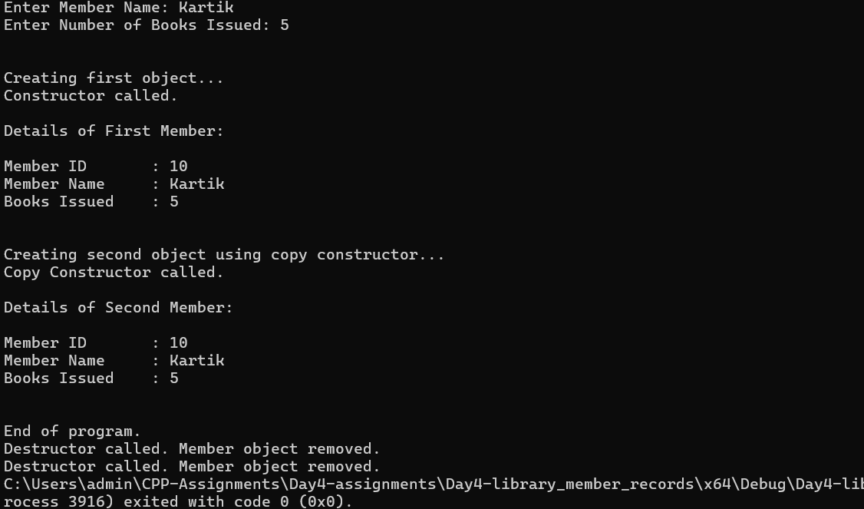

C++ Assignment 5 – Containment of Objects

Q.1.Assignment Problem Statement
Develop a C++ program for an Online Shopping Order Management System to demonstratecontainment of objects.

Requirements
• Create a class Customer with data members such as customerId, customerName, and
contactNumber.
• Provide suitable constructors and member functions to initialize and display customer
details.
• Create a class Product with data members such as productId, productName, price, and
quantity.
• Provide suitable constructors and member functions to initialize and display product details.
• Create a class Order that contains objects of both Customer and Product classes.
• The Order class should also store an orderId.
• Use constructors to initialize the contained Customer and Product objects.
• Calculate and display the total order amount based on product price and quantity.
• Create at least three Order objects and display complete order details.

Expected Output Details
For every order, display the Order ID, Customer details, Product details, Quantity, and Total

#include <iostream>
#include <iomanip>
#include <string>
using namespace std;

// CUSTOMER CLASS
class Customer
{
private:
int customerId;
string customerName;
string contactNumber;
public:
Customer(int id, string name, string contact)
{
customerId = id;
customerName = name;
contactNumber = contact;
}
// Display customer detail
void displayCustomer()
{
cout << "Customer ID : " << customerId << endl;
cout << "Customer Name : " << customerName << endl;
cout << "Contact Number : " << contactNumber << endl;
}
};
// PRODUCT CLASS
class Product
{
private:
int productId;
string productName;
double price;
int quantity;
public:
Product(int id, string name, double p, int q)
{
productId = id;
productName = name;
price = p;
quantity = q;
}
// Calculate total amount
double calculateTotal()
{
return price * quantity;
}
// Display product details
void displayProduct()
{
cout << "Product ID : " << productId << endl;
cout << "Product Name : " << productName << endl;
cout << "Price : Rs. " << fixed << setprecision(2) << price << endl;
cout << "Quantity : " << quantity << endl;
}
};
// ORDER CLASS
class Order
{
private:
int orderId;
// Containment of Customer object
Customer customer;
// Containment of Product object
Product product;
public:
// Constructor
Order(int id, Customer c, Product p)
: orderId(id), customer(c), product(p)
{
}
// Display complete order details
void displayOrder()
{
cout << "Order ID : " << orderId << endl;
cout << "\n--- Customer Details ---" << endl;
customer.displayCustomer();
cout << "\n--- Product Details ---" << endl;
product.displayProduct();
cout << "\nTotal Amount : Rs. " << fixed << setprecision(2) << << endl;
product.calculateTotal();
}
};
// MAIN FUNCTION
int main()
{
// Customer and Product for Order 1
Customer c1( 101, "Vanita", "9876543210");
Product p1( 501, "Laptop", 55000,1);
// Create Order 1
Order order1(1001,c1, p1);
// Customer and Product for Order 2
Customer c2(102,”Rahul”, "9876501234");
Product p2( 502, "Headphones", 2500,2);
// Create Order 2
Order order2(1002, c2, p2 );
// Customer and Product for Order 3
Customer c3(103, "Priya", "9123456780" );
Product p3( 503, "Smart Watch",4000,3);
// Create Order 3
Order order3( 1003, c3, p3);
// Display all orders
order1.displayOrder();
order2.displayOrder();
order3.displayOrder();
return 0;
}

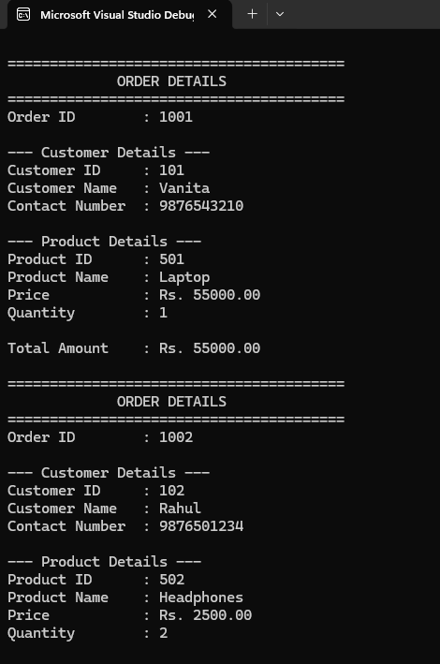

Assignment no - 6

The following assignments are designed to provide hands-on practice with inheritance, function
overriding, virtual functions, runtime polymorphism, abstract classes, base-class pointers and RTTI.

Problem 1: Hospital Billing System Using Inheritance, Polymorphism and RTTI
Domain: Hospital / Healthcare
Problem Statement
A hospital provides treatment to different categories of patients. The billing process differs depending on
the type of patient and the services provided.
Develop a Hospital Billing System using object-oriented programming concepts in C++. The system should
maintain patient information and calculate the final hospital bill according to the patient's category.
Create a base class named Patient that stores common details such as Patient ID, Patient Name, Age and
Number of Days Admitted.
Derive InPatient and OutPatient from Patient. Further derive EmergencyPatient from InPatient.
An InPatient may be charged for room charges, doctor consultation, medicines and treatment. An
OutPatient may be charged for consultation, diagnostic tests and medicines. An EmergencyPatient should
include inpatient charges along with emergency service charges and ambulance charges, if applicable.
The program should calculate and display the bill differently for each type of patient.
Requirements
• Create a base class Patient with common data members such as patientId, patientName, age and
numberOfDaysAdmitted.
• Provide appropriate constructors to initialize patient information.
• Create virtual functions such as calculateBill() and displayPatientDetails().
• Derive InPatient and OutPatient from Patient, and derive EmergencyPatient from InPatient.
• Override calculateBill() in InPatient, OutPatient and EmergencyPatient.
• Use suitable billing formulas for each patient category.
• Maintain different patient objects using Patient pointers, such as an array or vector of Patient
pointers.
• Demonstrate runtime polymorphism by calling calculateBill() and displayPatientDetails() through
Patient pointers.
• Use RTTI with dynamic_cast or typeid to identify the actual runtime type of each patient object.
• If an object is an EmergencyPatient, display additional information such as emergency charges,
ambulance charges and type of emergency.

• Perform safe casting by checking the result of dynamic_cast before accessing derived-class-specific
members.
• Include a virtual destructor in the Patient class.
• Create a menu-driven application with options to add different patient types, display all patients,
calculate bills and identify patient types using RTTI.
• Ensure that all dynamically created objects are properly deleted before program termination.

code
Patient.h
#ifndef PATIENT_H
#define PATIENT_H

#include <iostream>
#include <string>

using namespace std;

// ===============================
// PATIENT - BASE CLASS
// ===============================

class Patient
{
protected:

int patientId;
string patientName;
int age;
int numberOfDaysAdmitted;

public:

Patient(int id, string name, int a, int days)
{
patientId = id;
patientName = name;
age = a;
numberOfDaysAdmitted = days;
}

virtual void calculateBill() = 0;

virtual void displayPatientDetails()
{
cout << "Patient ID: " << patientId << endl;
cout << "Patient Name: " << patientName << endl;
cout << "Age: " << age << endl;
cout << "Days Admitted: " << numberOfDaysAdmitted << endl;
}

virtual ~Patient()
{
}
};

// ===============================
// INPATIENT
// ===============================

class InPatient : public Patient
{
protected:

float roomCharges;
float doctorCharges;
float medicineCharges;
float treatmentCharges;

public:

InPatient(
int id,
string name,
int a,
int days,
float room,
float doctor,
float medicine,
float treatment
)
: Patient(id, name, a, days)
{
roomCharges = room;
doctorCharges = doctor;
medicineCharges = medicine;
treatmentCharges = treatment;
}

void calculateBill() override
{
float bill;

bill = (roomCharges * numberOfDaysAdmitted)
+ doctorCharges
+ medicineCharges
+ treatmentCharges;

cout << "Total InPatient Bill = Rs. "
<< bill << endl;
}

void displayPatientDetails() override
{
cout << "\n----- INPATIENT -----" << endl;

Patient::displayPatientDetails();

cout << "Room Charges Per Day = Rs. "
<< roomCharges << endl;

cout << "Doctor Charges = Rs. "
<< doctorCharges << endl;

cout << "Medicine Charges = Rs. "
<< medicineCharges << endl;

cout << "Treatment Charges = Rs. "
<< treatmentCharges << endl;
}
};

// ===============================
// OUTPATIENT
// ===============================

class OutPatient : public Patient
{
private:

float consultationCharges;
float diagnosticCharges;
float medicineCharges;

public:

OutPatient(
int id,
string name,
int a,
float consultation,
float diagnostic,
float medicine
)
: Patient(id, name, a, 0)
{
consultationCharges = consultation;
diagnosticCharges = diagnostic;
medicineCharges = medicine;
}

void calculateBill() override
{
float bill;

bill = consultationCharges
+ diagnosticCharges
+ medicineCharges;

cout << "Total OutPatient Bill = Rs. "
<< bill << endl;
}

void displayPatientDetails() override
{
cout << "\n----- OUTPATIENT -----" << endl;

Patient::displayPatientDetails();

cout << "Consultation Charges = Rs. "
<< consultationCharges << endl;

cout << "Diagnostic Charges = Rs. "
<< diagnosticCharges << endl;

cout << "Medicine Charges = Rs. "
<< medicineCharges << endl;
}
};

// ===============================
// EMERGENCY PATIENT
// ===============================

class EmergencyPatient : public InPatient
{
private:

float emergencyCharges;
float ambulanceCharges;

string emergencyType;

bool ambulanceUsed;

public:

EmergencyPatient(
int id,
string name,
int a,
int days,
float room,
float doctor,
float medicine,
float treatment,
float emergency,
float ambulanceCharge,
string type,
bool used
)
: InPatient(
id,
name,
a,
days,
room,
doctor,
medicine,
treatment
)
{
emergencyCharges = emergency;
ambulanceCharges = ambulanceCharge;
emergencyType = type;
ambulanceUsed = used;
}

void calculateBill() override
{
float bill;

bill = (roomCharges * numberOfDaysAdmitted)
+ doctorCharges
+ medicineCharges
+ treatmentCharges
+ emergencyCharges;

if (ambulanceUsed == true)
{
bill = bill + ambulanceCharges;
}

cout << "Total Emergency Patient Bill = Rs. "
<< bill << endl;
}

void displayPatientDetails() override
{
cout << "\n----- EMERGENCY PATIENT -----"
<< endl;

Patient::displayPatientDetails();

cout << "Room Charges Per Day = Rs. "
<< roomCharges << endl;

cout << "Doctor Charges = Rs. "
<< doctorCharges << endl;

cout << "Medicine Charges = Rs. "
<< medicineCharges << endl;

cout << "Treatment Charges = Rs. "
<< treatmentCharges << endl;

cout << "Emergency Charges = Rs. "
<< emergencyCharges << endl;

cout << "Emergency Type = "
<< emergencyType << endl;

if (ambulanceUsed == true)
{
cout << "Ambulance Charges = Rs. "
<< ambulanceCharges << endl;
}
else
{
cout << "Ambulance = Not Used" << endl;
}
}

void displayEmergencyInfo()
{
cout << "Emergency Type = "
<< emergencyType << endl;

cout << "Emergency Charges = Rs. "
<< emergencyCharges << endl;

if (ambulanceUsed == true)
{
cout << "Ambulance Charges = Rs. "
<< ambulanceCharges << endl;
}
else
{
cout << "Ambulance = Not Used" << endl;
}
}
};

#endif

main.cpp
#include <iostream>
#include <vector>
#include "Patient.h"

using namespace std;

int main()
{
vector<Patient*> patients;

int choice;

do
{
cout << "\n======================================" << endl;
cout << " HOSPITAL BILLING SYSTEM" << endl;
cout << "======================================" << endl;

cout << "1. Add InPatient" << endl;
cout << "2. Add OutPatient" << endl;
cout << "3. Add Emergency Patient" << endl;
cout << "4. Display All Patients" << endl;
cout << "5. Calculate All Bills" << endl;
cout << "6. Identify Patient Type" << endl;
cout << "7. Exit" << endl;

cout << "\nEnter choice: ";
cin >> choice;

// =================================
// ADD INPATIENT
// =================================

if (choice == 1)
{
int id;
int age;
int days;

string name;

float room;
float doctor;
float medicine;
float treatment;

cout << "\nEnter Patient ID: ";
cin >> id;

cout << "Enter Patient Name: ";
cin >> name;

cout << "Enter Age: ";
cin >> age;

cout << "Enter Days Admitted: ";
cin >> days;

cout << "Enter Room Charges Per Day: ";
cin >> room;

cout << "Enter Doctor Charges: ";
cin >> doctor;

cout << "Enter Medicine Charges: ";
cin >> medicine;

cout << "Enter Treatment Charges: ";
cin >> treatment;

Patient* p = new InPatient(
id,
name,
age,
days,
room,
doctor,
medicine,
treatment
);

patients.push_back(p);

cout << "\nInPatient Added Successfully!" << endl;
}

// =================================
// ADD OUTPATIENT
// =================================

else if (choice == 2)
{
int id;
int age;

string name;

float consultation;
float diagnostic;
float medicine;

cout << "\nEnter Patient ID: ";
cin >> id;

cout << "Enter Patient Name: ";
cin >> name;

cout << "Enter Age: ";
cin >> age;

cout << "Enter Consultation Charges: ";
cin >> consultation;

cout << "Enter Diagnostic Test Charges: ";
cin >> diagnostic;

cout << "Enter Medicine Charges: ";
cin >> medicine;

Patient* p = new OutPatient(
id,
name,
age,
consultation,
diagnostic,
medicine
);

patients.push_back(p);

cout << "\nOutPatient Added Successfully!" << endl;
}

// =================================
// ADD EMERGENCY PATIENT
// =================================

else if (choice == 3)
{
int id;
int age;
int days;

string name;
string emergencyType;

float room;
float doctor;
float medicine;
float treatment;

float emergency;
float ambulanceCharge;

int ambulanceChoice;

cout << "\nEnter Patient ID: ";
cin >> id;

cout << "Enter Patient Name: ";
cin >> name;

cout << "Enter Age: ";
cin >> age;

cout << "Enter Days Admitted: ";
cin >> days;

cout << "Enter Room Charges Per Day: ";
cin >> room;

cout << "Enter Doctor Charges: ";
cin >> doctor;

cout << "Enter Medicine Charges: ";
cin >> medicine;

cout << "Enter Treatment Charges: ";
cin >> treatment;

cout << "Enter Emergency Charges: ";
cin >> emergency;

cout << "Enter Type of Emergency: ";
cin >> emergencyType;

cout << "Was Ambulance Used? (1 = Yes, 0 = No): ";
cin >> ambulanceChoice;

cout << "Enter Ambulance Charges: ";
cin >> ambulanceCharge;

Patient* p = new EmergencyPatient(
id,
name,
age,
days,
room,
doctor,
medicine,
treatment,
emergency,
ambulanceCharge,
emergencyType,
ambulanceChoice
);

patients.push_back(p);

cout << "\nEmergency Patient Added Successfully!"
<< endl;
}

// =================================
// DISPLAY ALL PATIENTS
// =================================

else if (choice == 4)
{
if (patients.empty())
{
cout << "\nNo Patients Available!" << endl;
}
else
{
cout << "\n========== ALL PATIENTS =========="
<< endl;

for (int i = 0; i < patients.size(); i++)
{
cout << "\nPatient "
<< i + 1 << endl;

patients[i]->displayPatientDetails();
}
}
}

// =================================
// CALCULATE ALL BILLS
// =================================

else if (choice == 5)
{
if (patients.empty())
{
cout << "\nNo Patients Available!" << endl;
}
else
{
cout << "\n========== ALL BILLS =========="
<< endl;

for (int i = 0; i < patients.size(); i++)
{
cout << "\nPatient "
<< i + 1 << endl;

patients[i]->calculateBill();
}
}
}

// =================================
// RTTI
// =================================

else if (choice == 6)
{
if (patients.empty())
{
cout << "\nNo Patients Available!" << endl;
}
else
{
cout << "\n========== PATIENT TYPES =========="
<< endl;

for (int i = 0; i < patients.size(); i++)
{
cout << "\nPatient "
<< i + 1 << ": ";

// Check EmergencyPatient first

EmergencyPatient* emergency =
dynamic_cast<EmergencyPatient*>(
patients[i]
);

if (emergency != nullptr)
{
cout << "Emergency Patient" << endl;

emergency->displayEmergencyInfo();
}

else
{
// Check InPatient

InPatient* inpatient =
dynamic_cast<InPatient*>(
patients[i]
);

if (inpatient != nullptr)
{
cout << "InPatient" << endl;
}

else
{
// Check OutPatient

OutPatient* outpatient =
dynamic_cast<OutPatient*>(
patients[i]
);

if (outpatient != nullptr)
{
cout << "OutPatient" << endl;
}
}
}
}
}
}

// =================================
// EXIT
// =================================

else if (choice == 7)
{
cout << "\nProgram Ended." << endl;
}

// =================================
// INVALID
// =================================

else
{
cout << "\nInvalid Choice!" << endl;
}

} while (choice != 7);

// =================================
// DELETE OBJECTS
// =================================

for (int i = 0; i < patients.size(); i++)
{
delete patients[i];
}

patients.clear();

return 0;
}

Output

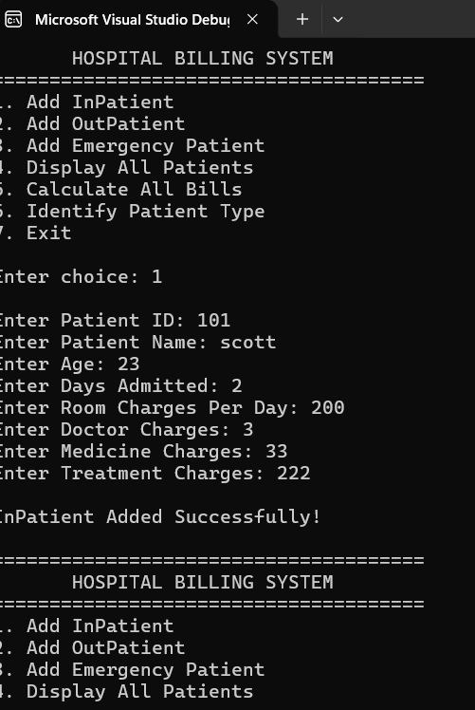

Problem 2: Financial Account Management System Using Inheritance, Polymorphismand RTTI
Domain: Finance / Banking
Problem Statement
A bank provides different types of accounts to its customers. Each account contains common information,
but the rules for calculating returns, handling withdrawals, overdraft facilities and maturity amounts
differ depending on the account type.
Develop a Financial Account Management System using inheritance, runtime polymorphism and RTTI.
Create a base class named Account containing common information such as Account Number, Customer
Name and Balance.
Derive SavingsAccount, CurrentAccount and FixedDepositAccount from Account. A savings account earns
interest based on its balance. A current account may provide an overdraft facility and apply service
charges. A fixed deposit account earns returns based on principal amount, interest rate and deposit
tenure.
The program should process all account types through a common base-class interface while also
identifying the actual account type at runtime.
Requirements
• Create a base class Account with data members such as accountNumber, customerName and balance.
• Provide suitable constructors for initializing account information.
• Declare virtual functions calculateReturns() and displayAccountInfo().
• Derive SavingsAccount, CurrentAccount and FixedDepositAccount from Account.
• Include additional data in SavingsAccount such as interestRate and minimumBalance.
• Override calculateReturns() to calculate interest earned by a savings account.
• Include overdraftLimit and serviceCharges in CurrentAccount and implement suitable withdrawal
rules.
• Include principal amount, interest rate and deposit tenure in FixedDepositAccount and calculate the
maturity amount.
• Store objects of all account types using Account pointers.
• Demonstrate runtime polymorphism by calling calculateReturns() and displayAccountInfo() through
Account pointers.
• Use dynamic_cast to identify the actual runtime account type.

• For SavingsAccount, display interest rate and minimum balance.
• For CurrentAccount, display overdraft limit and service charges.
• For FixedDepositAccount, display interest rate, deposit tenure and calculated maturity amount.

• Perform safe downcasting by checking the result of dynamic_cast before accessing derived-class-
specific members.

• Create a menu-driven application to create accounts, display accounts, calculate returns, perform
withdrawals and identify account types using RTTI.

1. Account.h

#ifndef ACCOUNT_H
#define ACCOUNT_H

#include <iostream>
#include <string>

using namespace std;

// ======================================
// BASE CLASS
// ======================================

class Account
{
protected:
int accountNumber;
string customerName;
double balance;

public:

Account(int number, string name, double bal)
{
accountNumber = number;
customerName = name;
balance = bal;
}

virtual void calculateReturns() = 0;

virtual void displayAccountInfo()
{
cout << "Account Number: " << accountNumber << endl;
cout << "Customer Name: " << customerName << endl;
cout << "Balance: Rs. " << balance << endl;
}

virtual void withdraw(double amount)
{
if (amount <= balance)
{
balance = balance - amount;
cout << "Withdrawal successful!" << endl;
cout << "Remaining Balance: Rs. "
<< balance << endl;
}
else
{
cout << "Insufficient balance!" << endl;
}
}

virtual ~Account()
{
}
};

// ======================================
// SAVINGS ACCOUNT
// ======================================

class SavingsAccount : public Account
{
private:
double interestRate;
double minimumBalance;

public:

SavingsAccount(
int number,
string name,
double bal,
double rate,
double minBal
)
: Account(number, name, bal)
{
interestRate = rate;
minimumBalance = minBal;
}

void calculateReturns() override
{
double interest;

interest = balance * interestRate / 100;

cout << "Interest Earned: Rs. "
<< interest << endl;
}

void displayAccountInfo() override
{
cout << "\n----- SAVINGS ACCOUNT -----" << endl;

Account::displayAccountInfo();

cout << "Interest Rate: "
<< interestRate << "%" << endl;

cout << "Minimum Balance: Rs. "
<< minimumBalance << endl;
}

void withdraw(double amount) override
{
if (balance - amount >= minimumBalance)
{
balance = balance - amount;

cout << "Withdrawal successful!" << endl;
cout << "Remaining Balance: Rs. "
<< balance << endl;
}
else
{
cout << "Withdrawal not allowed!" << endl;
cout << "Minimum balance must be maintained."
<< endl;
}
}
};

// ======================================
// CURRENT ACCOUNT
// ======================================

class CurrentAccount : public Account
{
private:
double overdraftLimit;
double serviceCharges;

public:

CurrentAccount(
int number,
string name,
double bal,
double overdraft,
double service
)
: Account(number, name, bal)
{
overdraftLimit = overdraft;
serviceCharges = service;
}

void calculateReturns() override
{
cout << "Current Account has no interest return."
<< endl;
}

void displayAccountInfo() override
{
cout << "\n----- CURRENT ACCOUNT -----" << endl;

Account::displayAccountInfo();

cout << "Overdraft Limit: Rs. "
<< overdraftLimit << endl;

cout << "Service Charges: Rs. "
<< serviceCharges << endl;
}

void withdraw(double amount) override
{
if (amount <= balance + overdraftLimit)
{
balance = balance - amount;
balance = balance - serviceCharges;

cout << "Withdrawal successful!" << endl;
cout << "Service charge deducted: Rs. "
<< serviceCharges << endl;

cout << "Remaining Balance: Rs. "
<< balance << endl;
}
else
{
cout << "Withdrawal exceeds overdraft limit!"
<< endl;
}
}
};

// ======================================
// FIXED DEPOSIT ACCOUNT
// ======================================

class FixedDepositAccount : public Account
{
private:
double principalAmount;
double interestRate;
int depositTenure;

public:

FixedDepositAccount(
int number,
string name,
double principal,
double rate,
int tenure
)
: Account(number, name, principal)
{
principalAmount = principal;
interestRate = rate;
depositTenure = tenure;
}

void calculateReturns() override
{
double interest;
double maturity;

interest = principalAmount
* interestRate
* depositTenure / 100;

maturity = principalAmount + interest;

cout << "Interest Earned: Rs. "
<< interest << endl;

cout << "Maturity Amount: Rs. "
<< maturity << endl;
}

void displayAccountInfo() override
{
cout << "\n----- FIXED DEPOSIT ACCOUNT -----"
<< endl;

Account::displayAccountInfo();

cout << "Principal Amount: Rs. "
<< principalAmount << endl;

cout << "Interest Rate: "
<< interestRate << "%" << endl;

cout << "Deposit Tenure: "
<< depositTenure << " years" << endl;

double interest;
double maturity;

interest = principalAmount
* interestRate
* depositTenure / 100;

maturity = principalAmount + interest;

cout << "Maturity Amount: Rs. "
<< maturity << endl;
}

void withdraw(double amount) override
{
cout << "Withdrawal is not allowed from Fixed Deposit"
<< endl;
}
};

#endif

main.cpp

#include <iostream>
#include <vector>
#include "Account.h"

using namespace std;

int main()
{
vector<Account*> accounts;

int choice;

do
{
cout << "\n======================================" << endl;
cout << " FINANCIAL ACCOUNT MANAGEMENT" << endl;
cout << "======================================" << endl;

cout << "1. Create Savings Account" << endl;
cout << "2. Create Current Account" << endl;
cout << "3. Create Fixed Deposit Account" << endl;
cout << "4. Display All Accounts" << endl;
cout << "5. Calculate Returns" << endl;
cout << "6. Withdraw Money" << endl;
cout << "7. Identify Account Type using RTTI" << endl;
cout << "8. Exit" << endl;

cout << "\nEnter choice: ";
cin >> choice;

// =====================================
// 1. SAVINGS ACCOUNT
// =====================================

if (choice == 1)
{
int number;
string name;
double balance;
double rate;
double minBalance;

cout << "\nEnter Account Number: ";
cin >> number;

cout << "Enter Customer Name: ";
cin >> name;

cout << "Enter Balance: ";
cin >> balance;

cout << "Enter Interest Rate (%): ";
cin >> rate;

cout << "Enter Minimum Balance: ";
cin >> minBalance;

Account* a = new SavingsAccount(
number,
name,
balance,
rate,
minBalance
);

accounts.push_back(a);

cout << "\nSavings Account Created Successfully!"
<< endl;
}

// =====================================
// 2. CURRENT ACCOUNT
// =====================================

else if (choice == 2)
{
int number;
string name;
double balance;
double overdraft;
double service;

cout << "\nEnter Account Number: ";
cin >> number;

cout << "Enter Customer Name: ";
cin >> name;

cout << "Enter Balance: ";
cin >> balance;

cout << "Enter Overdraft Limit: ";
cin >> overdraft;

cout << "Enter Service Charges: ";
cin >> service;

Account* a = new CurrentAccount(
number,
name,
balance,
overdraft,
service
);

accounts.push_back(a);

cout << "\nCurrent Account Created Successfully!"
<< endl;
}

// =====================================
// 3. FIXED DEPOSIT ACCOUNT
// =====================================

else if (choice == 3)
{
int number;
string name;

double principal;
double rate;

int tenure;

cout << "\nEnter Account Number: ";
cin >> number;

cout << "Enter Customer Name: ";
cin >> name;

cout << "Enter Principal Amount: ";
cin >> principal;

cout << "Enter Interest Rate (%): ";
cin >> rate;

cout << "Enter Deposit Tenure (years): ";
cin >> tenure;

Account* a = new FixedDepositAccount(
number,
name,
principal,
rate,
tenure
);

accounts.push_back(a);

cout << "\nFixed Deposit Account Created Successfully!"
<< endl;
}

// =====================================
// 4. DISPLAY ALL ACCOUNTS
// =====================================

else if (choice == 4)
{
if (accounts.empty())
{
cout << "\nNo Accounts Available!" << endl;
}
else
{
cout << "\n========== ALL ACCOUNTS =========="
<< endl;

for (int i = 0; i < accounts.size(); i++)
{
cout << "\nAccount "
<< i + 1 << endl;

// Runtime Polymorphism
accounts[i]->displayAccountInfo();
}
}
}

// =====================================
// 5. CALCULATE RETURNS
// =====================================

else if (choice == 5)
{
if (accounts.empty())
{
cout << "\nNo Accounts Available!" << endl;
}
else
{
cout << "\n========== ACCOUNT RETURNS =========="
<< endl;

for (int i = 0; i < accounts.size(); i++)
{
cout << "\nAccount "
<< i + 1 << ":" << endl;

// Runtime Polymorphism
accounts[i]->calculateReturns();
}
}
}

// =====================================
// 6. WITHDRAW MONEY
// =====================================

else if (choice == 6)
{
if (accounts.empty())
{
cout << "\nNo Accounts Available!" << endl;
}
else
{
int index;
double amount;

cout << "\nEnter Account Number from list (1 - "
<< accounts.size() << "): ";

cin >> index;

if (index >= 1 && index <= accounts.size())
{
cout << "Enter Amount to Withdraw: ";
cin >> amount;

accounts[index - 1]->withdraw(amount);
}
else
{
cout << "Invalid Account!" << endl;
}
}
}

// =====================================
// 7. RTTI
// =====================================

else if (choice == 7)
{
if (accounts.empty())
{
cout << "\nNo Accounts Available!" << endl;
}
else
{
cout << "\n========== ACCOUNT TYPES =========="
<< endl;

for (int i = 0; i < accounts.size(); i++)
{
cout << "\nAccount "
<< i + 1 << ": ";

// Check SavingsAccount

SavingsAccount* savings =
dynamic_cast<SavingsAccount*>(
accounts[i]
);

if (savings != nullptr)
{
cout << "Savings Account" << endl;
}

else
{
// Check CurrentAccount

CurrentAccount* current =
dynamic_cast<CurrentAccount*>(
accounts[i]
);

if (current != nullptr)
{
cout << "Current Account" << endl;
}

else
{
// Check FixedDepositAccount

FixedDepositAccount* fd =
dynamic_cast<FixedDepositAccount*>(
accounts[i]
);

if (fd != nullptr)
{
cout << "Fixed Deposit Account"
<< endl;
}
}
}
}
}
}

// =====================================
// 8. EXIT
// =====================================

else if (choice == 8)
{
cout << "\nProgram Ended." << endl;
}

else
{
cout << "\nInvalid Choice!" << endl;
}

} while (choice != 8);

// =====================================
// DELETE DYNAMIC OBJECTS
// =====================================

for (int i = 0; i < accounts.size(); i++)
{
delete accounts[i];
}

accounts.clear();

return 0;
}

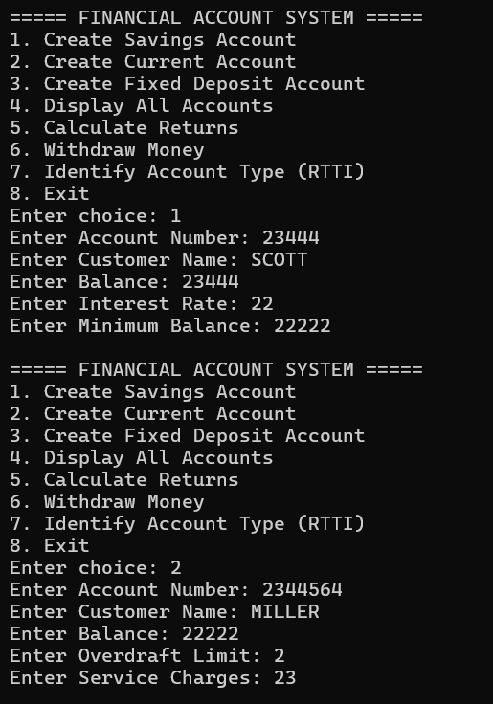

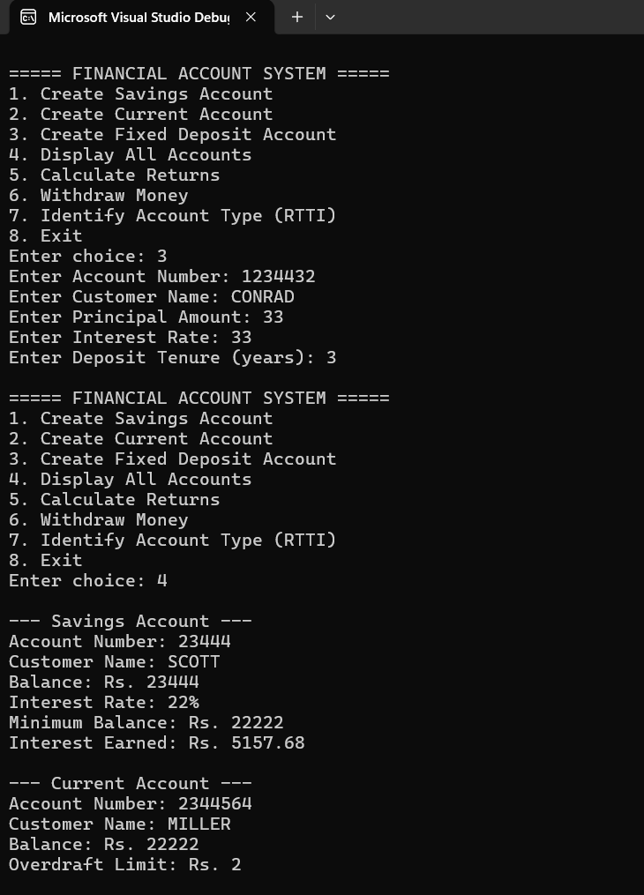
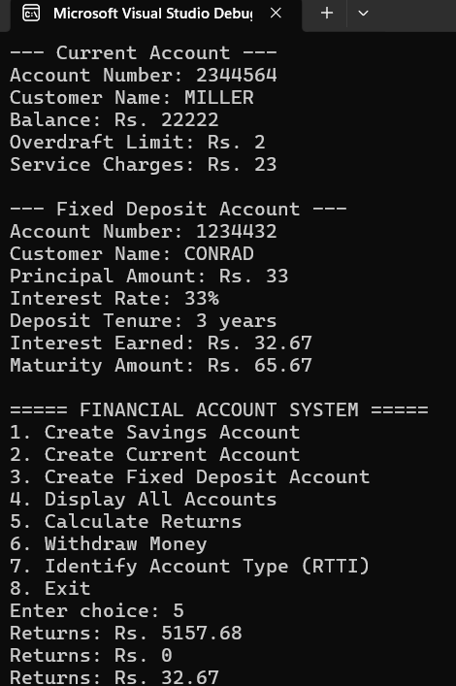

Assignment no-7

Q1.Airline Baggage & Boarding Pass Fee Engine

A Comprehensive Problem Statement on C++ Abstract Classes, Pure Virtual Functions, Dynamic Memory

Allocation, and Runtime Polymorphism

#pragma once
#include <iostream>
#include <string>
#include <iomanip>
using namespace std;

// Abstract Base Class
class FlightTicket
{
protected:
string passengerName;
string flightNumber;
double baseFare;

public:
FlightTicket(string name, string flightNo, double fare)
{
passengerName = name;
flightNumber = flightNo;
baseFare = fare;
}

// Pure virtual functions
virtual double calculateTotalFare(int baggageCount,
double totalWeightKg) = 0;

virtual void printBoardingPass() = 0;

// Virtual destructor
virtual ~FlightTicket()
{
}
};

#pragma once
#include"FlightTicket.h";

// First Class Ticket
class FirstClassTicket : public FlightTicket
{
protected:
double conciergeServiceFee;

public:
FirstClassTicket(string name, string flightNo, double fare,
double conciergeFee)
: FlightTicket(name, flightNo, fare)
{
conciergeServiceFee = conciergeFee;
}

double calculateTotalFare(int baggageCount,
double totalWeightKg)
{
double baggageCharge = 0;

// Flat $100 penalty if weight > 50 kg
if (totalWeightKg > 50)
{
baggageCharge = 100;
}

return baseFare +
conciergeServiceFee +
baggageCharge;
}

void printBoardingPass()
{
cout << "\n[BOARDING PASS - FIRST CLASS]\n";
cout << "Passenger : " << passengerName << endl;
cout << "Flight Number : " << flightNumber << endl;
cout << "Base Fare : $" << baseFare << endl;
cout << "Concierge Fee : $" << conciergeServiceFee << endl;
}
};

#pragma once
#include"FlightTicket.h";
// Economy Ticket
class EconomyTicket : public FlightTicket
{
protected:
double extraBagFeePerKg;
double seatSelectionFee;

public:
EconomyTicket(string name, string flightNo, double fare,
double extraFee, double seatFee)
: FlightTicket(name, flightNo, fare)
{
extraBagFeePerKg = extraFee;
seatSelectionFee = seatFee;
}
double calculateTotalFare(int baggageCount,
double totalWeightKg)
{
double baggageCharge = 0;

// Weight above 15 kg
if (totalWeightKg > 15)
{
baggageCharge =
(totalWeightKg - 15) * extraBagFeePerKg;
}

// Extra bags after first bag
if (baggageCount > 1)
{
baggageCharge =
baggageCharge + (baggageCount - 1) * 50;
}
return baseFare + seatSelectionFee + baggageCharge;
}
void printBoardingPass()
{
cout << "\n[BOARDING PASS - ECONOMY CLASS]\n";
cout << "Passenger : " << passengerName << endl;
cout << "Flight Number : " << flightNumber << endl;
cout << "Base Fare : $" << baseFare << endl;
cout << "Seat Fee : $" << seatSelectionFee << endl;
}
};

#pragma once
#include"FlightTicket.h";

// Business Ticket
class BusinessTicket : public FlightTicket
{
protected:
double loungeAccessFee;
double priorityBoardingFee;

public:
BusinessTicket(string name, string flightNo, double fare,
double loungeFee, double priorityFee)
: FlightTicket(name, flightNo, fare)
{
loungeAccessFee = loungeFee;
priorityBoardingFee = priorityFee;
}

double calculateTotalFare(int baggageCount,
double totalWeightKg)
{
double baggageCharge = 0;

// Weight above 32 kg
if (totalWeightKg > 32)
{
baggageCharge =
(totalWeightKg - 32) * 20;
}

return baseFare +
loungeAccessFee +
priorityBoardingFee +
baggageCharge;
}
void printBoardingPass()
{
cout << "\n[BOARDING PASS - BUSINESS CLASS]\n";
cout << "Passenger : " << passengerName << endl;
cout << "Flight Number : " << flightNumber << endl;
cout << "Base Fare : $" << baseFare << endl;
cout << "Lounge Fee : $" << loungeAccessFee << endl;
cout << "Priority Fee : $" << priorityBoardingFee << endl;
}
};

#include<iostream>
#include"FlightTicket.h";
#include "EconomyTicket.h"
#include "BusinessTicket.h"
#include "FirstClassTicket.h"
using namespace std;

// Main Function

int main()
{
int N;

cout << "=== AIRLINE BAGGAGE & BOARDING PASS SYSTEM ===\n";

cout << "Enter number of passenger bookings: ";
cin >> N;

// Dynamic array of base class pointers
FlightTicket** manifest = new FlightTicket * [N];

double totalRevenue = 0;

for (int i = 0; i < N; i++)
{
cout << "\n--- Passenger #" << i + 1 << " ---\n";
int choice;
string name;
string flightNo;
double fare;
int baggageCount;
double weight;

cout << "Select Fare Class\n";
cout << "1. Economy\n";
cout << "2. Business\n";
cout << "3. First Class\n";
cout << "Enter choice: ";
cin >> choice;

cin.ignore();

cout << "Enter Passenger Name: ";
getline(cin, name);

cout << "Enter Flight Number: ";
cin >> flightNo;

cout << "Enter Base Fare: $";
cin >> fare;

cout << "Enter Baggage Count: ";
cin >> baggageCount;

cout << "Enter Total Baggage Weight (kg): ";
cin >> weight;

// Create required object dynamically
if (choice == 1)
{
double extraFee;
double seatFee;

cout << "Enter Extra Bag Fee per Kg: $";
cin >> extraFee;

cout << "Enter Seat Selection Fee: $";
cin >> seatFee;

manifest[i] = new EconomyTicket(
name, flightNo, fare,
extraFee, seatFee
);
}

else if (choice == 2)
{
double loungeFee;
double priorityFee;

cout << "Enter Lounge Access Fee: $";
cin >> loungeFee;

cout << "Enter Priority Boarding Fee: $";
cin >> priorityFee;

manifest[i] = new BusinessTicket(
name, flightNo, fare,
loungeFee, priorityFee
);
}

else if (choice == 3)
{
double conciergeFee;

cout << "Enter Concierge Service Fee: $";
cin >> conciergeFee;

manifest[i] = new FirstClassTicket(
name, flightNo, fare,
conciergeFee
);
}

else
{
cout << "Invalid choice!\n";
i--;
continue;
}

// Runtime polymorphism
double totalFare =
manifest[i]->calculateTotalFare(
baggageCount, weight
);

manifest[i]->printBoardingPass();

cout << "Total Fare : $"
<< fixed << setprecision(2)
<< totalFare << endl;

totalRevenue = totalRevenue + totalFare;
}

// Revenue summary
cout << "\n========================================\n";
cout << " FLIGHT REVENUE SUMMARY\n";
cout << "========================================\n";

cout << "Total Passengers : " << N << endl;

cout << "Total Revenue : $"
<< fixed << setprecision(2)
<< totalRevenue << endl;

// Free memory
for (int i = 0; i < N; i++)
{
delete manifest[i];
}

delete[] manifest;

manifest = nullptr;

cout << "\nMemory cleaned successfully.\n";

return 0;
}

/*== = AIRLINE BAGGAGE & BOARDING PASS SYSTEM == =
Enter number of passenger bookings : 30

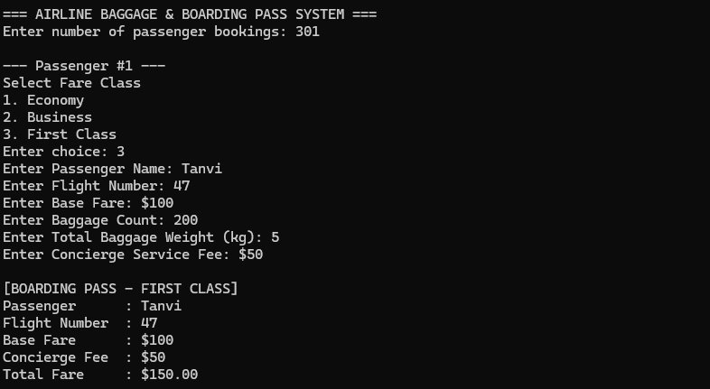

Q.2 Automated Investment Portfolio & Yield Analyzer
A Comprehensive Problem Statement on C++ Abstract Classes, Pure Virtual Functions, Dynamic Memory
Allocation, and Runtime Polymorphism

#pragma once
#include <iostream>
#include <iomanip>
#include <string>
using namespace std;

// BASE CLASS : InvestmentAsset

class InvestmentAsset
{
protected:
string assetTicker;
string assetName;
double initialPrincipal;
public:
InvestmentAsset(string ticker, string name, double principal)
{
assetTicker = ticker;
assetName = name;
initialPrincipal = principal;
}
// Pure virtual functions
virtual double calculateProjectedValue(int durationYears) = 0;

virtual double calculateRiskScore() = 0;

virtual void displayStatement(int durationYears) = 0;
// Getter
double getInitialPrincipal()
{
return initialPrincipal;
}

// Virtual destructor
virtual ~InvestmentAsset()
{
}
};

#pragma once
#include"InvestmentAsset.h";
// DERIVED CLASS : RealEstateTrust
class RealEstateTrust : public InvestmentAsset
{
private:
double rentalCapRate;
double propertyAppreciationRate;
double managementFeeRate;
public:
RealEstateTrust(
string ticker,
string name,
double principal,
double rentalRate,
double appreciationRate,
double managementFee
) : InvestmentAsset(ticker, name, principal)
{
rentalCapRate = rentalRate;
propertyAppreciationRate = appreciationRate;
managementFeeRate = managementFee;
}
double calculateProjectedValue(int durationYears) override
{
double netRate = rentalCapRate + propertyAppreciationRate - managementFeeRate;
double value = initialPrincipal;
for (int i = 0; i < durationYears; i++)
{
value = value * (1 + netRate);
}
return value;
}
double calculateRiskScore() override
{
return 3.5;
}
void displayStatement(int durationYears) override
{
cout << "\n--- Real Estate Trust (REIT) ---"<< endl;
cout << "Ticker: "<< assetTicker << endl;
cout << "Name: " << assetName << endl;
cout << "Initial Investment: $" << fixed << setprecision(2) << initialPrincipal << endl;
cout << "Projected Value: $" << calculateProjectedValue(durationYears) << endl;
cout << "Risk Score: " << calculateRiskScore() << " / 10" << endl;

}
};
#pragma once
#include"InvestmentAsset.h";
// DERIVED CLASS : EquityStock
class EquityStock : public InvestmentAsset
{
private:
double annualGrowthRate;
double dividendYield;
double beta;
public:
EquityStock(
string ticker,
string name,
double principal,
double growthRate,
double dividend,
double betaValue
) : InvestmentAsset(ticker, name, principal)
{
annualGrowthRate = growthRate;
dividendYield = dividend;
beta = betaValue;
}
// Calculate projected value
double calculateProjectedValue(int durationYears) override
{
double rate = annualGrowthRate + dividendYield;
double value = initialPrincipal;
for (int i = 0; i < durationYears; i++)
{
value = value * (1 + rate);
}

return value;
}
// Calculate risk
double calculateRiskScore() override
{
double risk = beta * 4.5;
if (risk > 10.0)
{
risk = 10.0;
}
if (risk < 1.0)
{
risk = 1.0;
}

return risk;
}

// Display statement
void displayStatement(int durationYears) override
{
cout << "\n--- Equity Stock ---" << endl;

cout << "Ticker: "
<< assetTicker << endl;

cout << "Name: "
<< assetName << endl;

cout << "Initial Investment: $"
<< fixed << setprecision(2)
<< initialPrincipal << endl;

cout << "Projected Value: $"
<< calculateProjectedValue(durationYears)
<< endl;

cout << "Risk Score: "
<< calculateRiskScore()
<< " / 10" << endl;
}
};

#pragma once
#include"InvestmentAsset.h";
// DERIVED CLASS : CryptoStaking
class CryptoStaking : public InvestmentAsset
{
private:
double stakingAPY;
double networkSlashingPenaltyRate;
public:
CryptoStaking(
string ticker,
string name,
double principal,
double apy,
double penaltyRate
) : InvestmentAsset(ticker, name, principal)
{
stakingAPY = apy;
networkSlashingPenaltyRate = penaltyRate;
}
// Calculate projected value
double calculateProjectedValue(int durationYears) override
{
double effectiveYield =
stakingAPY
- networkSlashingPenaltyRate;
double value = initialPrincipal;
for (int i = 0; i < durationYears; i++)
{
value = value * (1 + effectiveYield);
}
return value;
}
// Risk is fixed for Crypto
double calculateRiskScore() override
{
return 8.5;
}
// Display statement
void displayStatement(int durationYears) override
{
cout << "\n--- Crypto Staking ---"
<< endl;

cout << "Ticker: "
<< assetTicker << endl;

cout << "Name: "
<< assetName << endl;

cout << "Initial Investment: $"
<< fixed << setprecision(2)
<< initialPrincipal << endl;

cout << "Projected Value: $"
<< calculateProjectedValue(durationYears)
<< endl;

cout << "Risk Score: "
<< calculateRiskScore()
<< " / 10" << endl;
}
};

// MAIN FUNCTION

#include<iostream>
#include"InvestmentAsset.h";
#include"EquityStock.h";
#include"RealEstateTrust.h";
#include"CryptoStaking.h";
#include<string>
using namespace std;
int main()
{
int N;
cout << "Enter number of investments: ";
cin >> N;
// Dynamic array of base class pointers
InvestmentAsset** portfolio = new InvestmentAsset * [N];

// INPUT INVESTMENT DETAILS
for (int i = 0; i < N; i++)
{
int choice;
cout << "\n================================" << endl;
cout << "Investment " << i + 1 << endl;
cout << "================================" << endl;
cout << "1. Equity Stock" << endl;
cout << "2. Real Estate Trust" << endl;
cout << "3. Crypto Staking" << endl;
cout << "Enter choice: ";
cin >> choice;
string ticker;
string name;
double principal;
cout << "Enter asset ticker: ";
cin >> ticker;
cout << "Enter asset name: ";
cin >> name;
cout << "Enter initial investment: ";
cin >> principal;

// EQUITY STOCK

if (choice == 1)
{
double growthRate;
double dividend;
double beta;
cout << "Enter annual growth rate: ";
cin >> growthRate;

cout << "Enter dividend yield: ";
cin >> dividend;
cout << "Enter beta: ";
cin >> beta;
portfolio[i] =
new EquityStock(
ticker,
name,
principal,
growthRate,
dividend,
beta
);
}

// REAL ESTATE TRUST

else if (choice == 2)
{
double rentalRate;
double appreciationRate;
double managementFee;
cout << "Enter rental cap rate: ";
cin >> rentalRate;
cout << "Enter property appreciation rate: ";
cin >> appreciationRate;
cout << "Enter management fee rate: ";
cin >> managementFee;
portfolio[i] =
new RealEstateTrust(
ticker,
name,
principal,
rentalRate,
appreciationRate,
managementFee
);
}

// CRYPTO STAKING

else if (choice == 3)
{
double apy;
double penalty;

cout << "Enter staking APY: ";
cin >> apy;
cout << "Enter network slashing penalty rate: ";
cin >> penalty;
portfolio[i] =
new CryptoStaking(
ticker,
name,
principal,
apy,
penalty
);
}
// INVALID CHOICE
else
{
cout << "Invalid choice!" << endl;

delete[] portfolio;

return 0;
}
}
int durationYears;
cout << "\nEnter investment duration in years: ";
cin >> durationYears;

// CALCULATE AGGREGATE VALUES

double totalInitialCapital = 0;
double totalProjectedValue = 0;
double weightedRisk = 0;
cout << "\n\n========================================" << endl;
cout << " INVESTMENT STATEMENTS" << endl;
cout << "========================================" << endl;

// Runtime polymorphism
for (int i = 0; i < N; i++)
{
portfolio[i]->displayStatement(durationYears);
double initial =
portfolio[i]->getInitialPrincipal();
double projected =
portfolio[i]->calculateProjectedValue(
durationYears
);

double risk =
portfolio[i]->calculateRiskScore();

// Total initial capital
totalInitialCapital = totalInitialCapital + initial;

// Total projected value
totalProjectedValue = totalProjectedValue + projected;

// Weighted risk
weightedRisk =weightedRisk + (initial * risk);
}

// CALCULATE PROFIT / LOSS
double profitLoss =
totalProjectedValue
- totalInitialCapital;

// WEIGHTED AVERAGE RISK
weightedRisk =
weightedRisk / totalInitialCapital;

// FINAL PORTFOLIO REPORT
cout << "\n\n========================================" << endl;
cout << " PORTFOLIO SUMMARY"<< endl;
cout << "========================================"<< endl;
cout << fixed << setprecision(2);
cout << "Total Initial Capital: $" << totalInitialCapital << endl;
cout << "Total Projected Value: $" << totalProjectedValue << endl;
cout << "Projected Profit/Loss: $" << profitLoss << endl;
cout << "Portfolio Weighted Average Risk: " << weightedRisk << " / 10" << endl;

// DEALLOCATE MEMORY

for (int i = 0; i < N; i++)
{
delete portfolio[i];
}

delete[] portfolio;

portfolio = nullptr;

return 0;
}
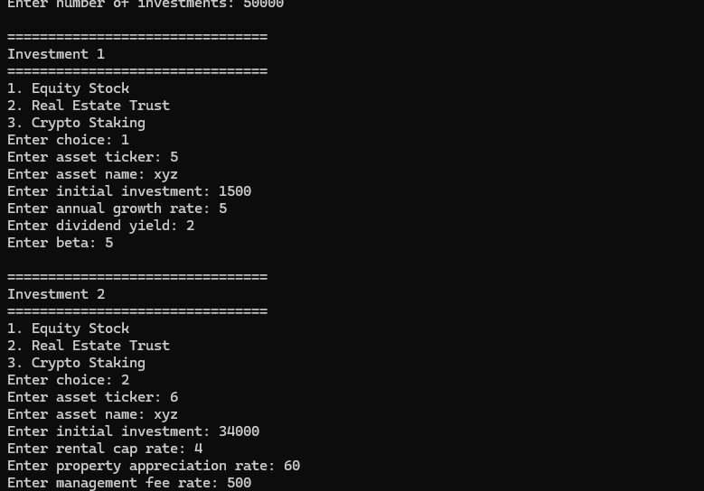

Assignment no-8

C++ Assignment: Custom Exceptions
and Stream Operator Overloading

Domain: Banking / Digital Wallet System

Problem Statement
Develop a C++ application to manage a simple Digital Wallet system. The system should
store wallet holder details and wallet balance. The application must demonstrate the use of
custom exception handling and operator overloading for the insertion (<<) and extraction
(>>) operators.

Class Requirements
• Create a class Wallet with the following data members:
• walletId
• holderName
• balance
Provide suitable constructors and member functions to initialize and display wallet details.

Custom Exception Requirements
• Create a custom exception class InvalidAmountException.
• Throw the exception when the user enters an invalid transaction amount, such as zero
or a negative value.
• Create another custom exception class InsufficientBalanceException.
• Throw the exception when a withdrawal amount is greater than the available wallet
balance.
• Handle all exceptions using appropriate try-catch blocks and display meaningful error
messages.

Operator Overloading Requirements
• Overload the >> operator to accept Wallet details from the user.
• Overload the << operator to display Wallet details in a formatted manner.
• Implement these operators as friend functions.

Functional Requirements
1. Accept wallet details using the overloaded >> operator.
2. Display wallet details using the overloaded << operator.
3. Provide options to add money and withdraw money.
4. Validate transaction amounts using custom exceptions.
5. Display the updated wallet information after every successful transaction.
6. Use a menu-driven program to perform multiple operations until the user chooses to
exit.

Expected Learning Outcomes
• Understand and implement user-defined/custom exception classes.
• Use throw and try-catch blocks for exception handling.
• Overload the stream insertion operator (<<).
• Overload the stream extraction operator (>>).
• Understand the use of friend functions in operator overloading.
• Design a menu-driven object-oriented C++ application.

Sample Menu
1. Create Wallet
2. Add Money
3. Withdraw Money
4. Display Wallet Details
5. Exit

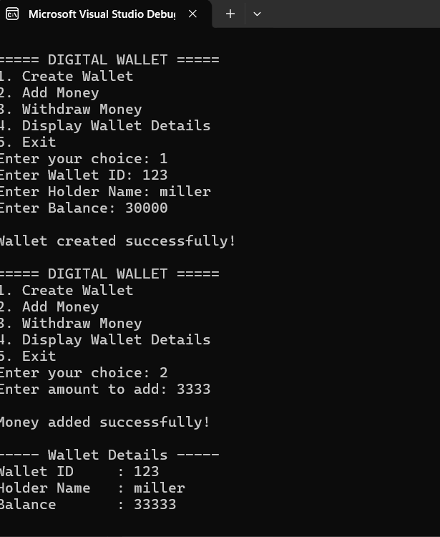

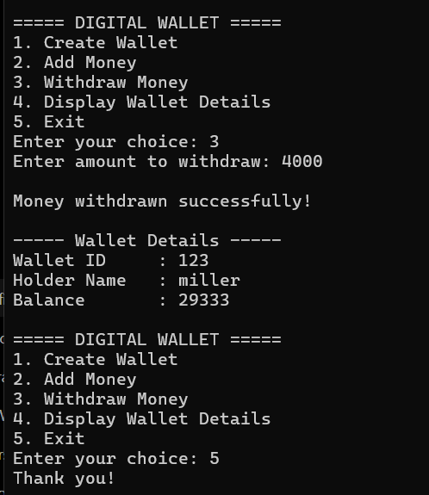

ASSIGNMENT 9

PART A: FILE HANDLING IN C++Stream classes :(ifstream, ofstream, fstream), text & binary mode, stream position pointers, error flags
Problem 1.2: Binary Student Database
Problem Description:
Design and implement an offline Student Information Records System using binary file persistence('students.dat'). The system must handle n student records without loading the entire dataset into main memory, performing direct record access
Functional & Technical Requirements:
• Define a structure or class 'StudentRecord' with fields: Roll Number (int), Full Name (char array of size 50),Department (char array of size 20), CGPA (float), and Active Status (bool).
• Menu-driven operations: (1) Add New Student, (2) Display All Active Records, (3) Search Student by Roll Number
• Implement proper file open modes: ios::in | ios::out | ios::binary | ios::app.
CODE:
1)StudentRecord.h file:
#ifndef STUDENTRECORD_H
#define STUDENTRECORD_H

#include <iostream>
#include <fstream>
using namespace std;

class StudentRecord
{
private:
int rollNo;
char fullName[50];
char department[20];
float cgpa;
bool active;

public:
StudentRecord();

void accept();
void display() const;

int getRollNo() const;
bool isActive() const;
};

#endif
2)StudentRecord1.h file:
#include "StudentRecord.h"
#include <cstring>

StudentRecord::StudentRecord()
{
rollNo = 0;
fullName[0] = '\0';
department[0] = '\0';
cgpa = 0.0;
active = true;
}

void StudentRecord::accept()
{
cout << "Enter Roll Number: ";
cin >> rollNo;

cin.ignore();

cout << "Enter Full Name: ";
cin.getline(fullName, 50);

cout << "Enter Department: ";
cin.getline(department, 20);

cout << "Enter CGPA: ";
cin >> cgpa;

active = true;
}

void StudentRecord::display() const
{
cout << "\nRoll Number : " << rollNo;
cout << "\nFull Name : " << fullName;
cout << "\nDepartment : " << department;
cout << "\nCGPA : " << cgpa;
cout << "\nStatus : "
<< (active ? "Active" : "Inactive");
cout << "\n";
}

int StudentRecord::getRollNo() const
{
return rollNo;
}

bool StudentRecord::isActive() const
{
return active;
}
3)Main cpp file:
#include <iostream>
#include <fstream>
#include "StudentRecord.h"

using namespace std;

void addStudent()
{
fstream file;

file.open("students.dat",
ios::in |
ios::out |
ios::binary |
ios::app);

if (!file)
{
cout << "Error opening file!" << endl;
return;
}

StudentRecord s;

s.accept();

file.write(
reinterpret_cast<char*>(&s),
sizeof(s)
);

if (file)
cout << "\nRecord added successfully.\n";
else
cout << "\nError writing record.\n";

file.close();
}

void displayAllActive()
{
fstream file;

file.open("students.dat",
ios::in |
ios::out |
ios::binary |
ios::app);

if (!file)
{
cout << "Error opening file!" << endl;
return;
}

StudentRecord s;

bool found = false;

file.seekg(0, ios::beg);

cout << "\n===== ACTIVE STUDENT RECORDS =====\n";

while (file.read(
reinterpret_cast<char*>(&s),
sizeof(s)))
{
if (s.isActive())
{
s.display();
found = true;
}
}

if (!found)
cout << "No active records found.\n";

file.close();
}

void searchStudent()
{
fstream file;

file.open("students.dat",
ios::in |
ios::out |
ios::binary |
ios::app);

if (!file)
{
cout << "Error opening file!" << endl;
return;
}

int roll;
bool found = false;

cout << "Enter Roll Number to search: ";
cin >> roll;

StudentRecord s;

file.seekg(0, ios::beg);

while (file.read(
reinterpret_cast<char*>(&s),
sizeof(s)))
{
if (s.getRollNo() == roll)
{
found = true;

cout << "\nStudent Found:\n";
s.display();

break;
}
}

if (!found)
{
cout << "\nStudent not found.\n";
}

file.close();
}

int main()
{
int choice;

do
{
cout << "\n==============================";
cout << "\n STUDENT DATABASE";
cout << "\n==============================";
cout << "\n1. Add New Student";
cout << "\n2. Display All Active Records";
cout << "\n3. Search Student by Roll Number";
cout << "\n4. Exit";
cout << "\nEnter choice: ";

cin >> choice;

switch (choice)
{
case 1:
addStudent();
break;

case 2:
displayAllActive();
break;

case 3:
searchStudent();
break;

case 4:
cout << "Exiting...\n";
break;

default:
cout < "Invalid choice!\n";
}

} while (choice != 4);

return 0;
}

OUTPUT:

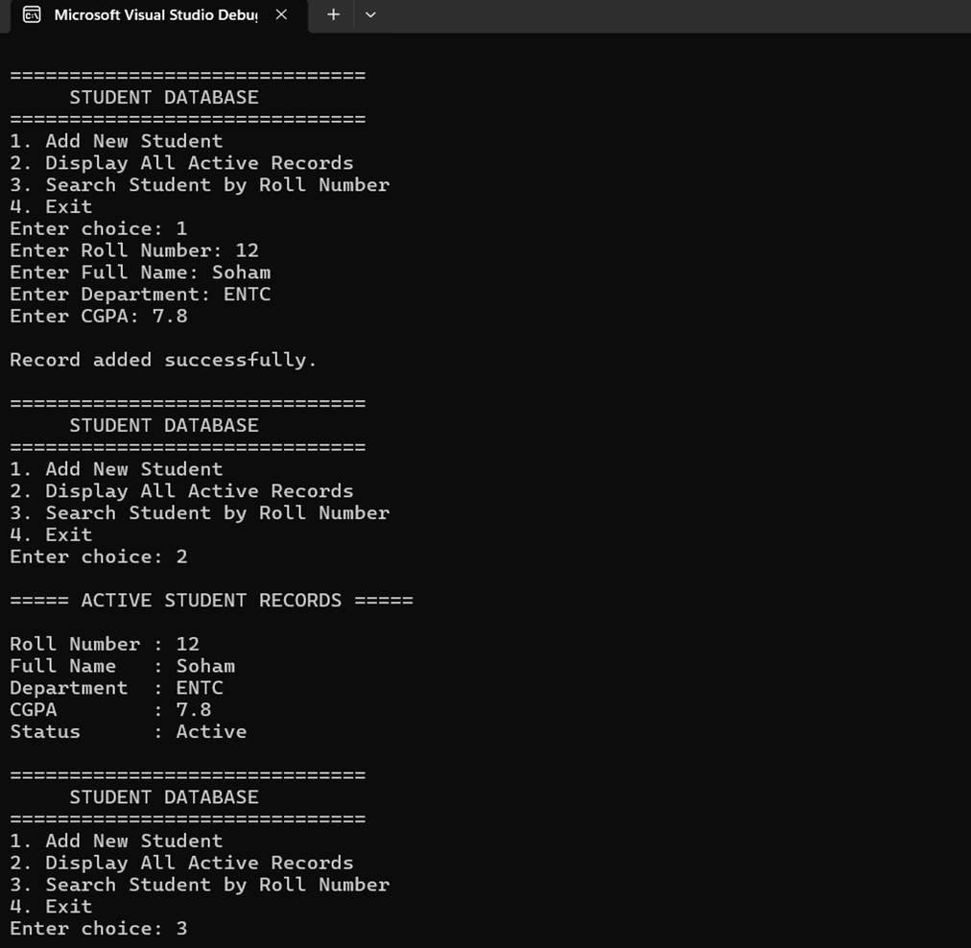

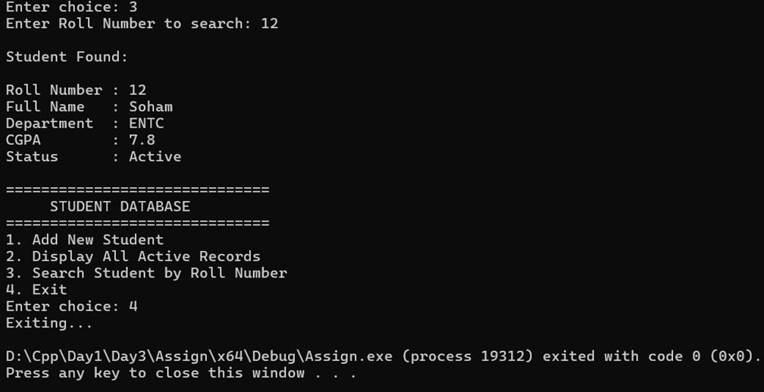

PART B: FUNCTION TEMPLATES: Generic algorithms, multi-type parameters, template specialization, and custom object comparison
Problem 2.1: Generic Statistical Pipeline with Template Specialization [Intermediate | Marks: 10 Marks]
Objective: Implement generic function templates handling various primitive numeric types and explicit template specialization for string types.
Problem Description:
In algorithmic data pipelines, functions must execute uniform math operations over multiple data formats (int, float, double). Construct a modular library of generic function templates to compute descriptive statistics across generic arrays, along with a specialized handling mechanism for lexicographical string analysis.
Functional & Technical Requirements:
• Implement template function 'findMinMax(T arr[], int size, T &minVal, T &maxVal)' to return max and min in a single pass.
• Implement template function 'computeAverage(T arr[], int size)' returning double precision mean for numeric arrays.
• Test templates in main() with: (a) int array, (b) double array, and (c) string array.
CODE:
1) Statistics.h File
#ifndef STATISTICS_H
#define STATISTICS_H

#include <string>
using namespace std;

// =================================================
// Generic findMinMax()
// =================================================

template <typename T>
void findMinMax(
T arr[],
int size,
T& minVal,
T& maxVal)
{
minVal = arr[0];
maxVal = arr[0];

for (int i = 1; i < size; i++)
{
if (arr[i] < minVal)
{
minVal = arr[i];
}

if (arr[i] > maxVal)
{
maxVal = arr[i];
}
}
}

// =================================================
// Generic computeAverage()
// =================================================

template <typename T>
double computeAverage(
T arr[],
int size)
{
double sum = 0;

for (int i = 0; i < size; i++)
{
sum += arr[i];
}

return sum / size;
}

// =================================================
// String specialization
//
// Here minVal = shortest string
// and maxVal = longest string
// =================================================

template <>
void findMinMax<string>(
string arr[],
int size,
string& minVal,
string& maxVal)
{
minVal = arr[0];
maxVal = arr[0];

for (int i = 1; i < size; i++)
{
if (arr[i].length() < minVal.length())
{
minVal = arr[i];
}

if (arr[i].length() > maxVal.length())
{
maxVal = arr[i];
}
}
}

#endif
2)Main cpp file:
#include <iostream>
#include <iomanip>
#include <string>

#include "Statistics.h"

using namespace std;

int main()
{
// =========================================
// INTEGER ARRAY
// =========================================

int arr1[] = {45, 12, 89, 3, 27};

int size1 = sizeof(arr1) / sizeof(arr1[0]);

int min1, max1;

findMinMax(
arr1,
size1,
min1,
max1
);

double avg1 =
computeAverage(arr1, size1);

cout << "Array<int>: ";

for (int i = 0; i < size1; i++)
{
cout << arr1[i];

if (i != size1 - 1)
cout << ", ";
}

cout << "\nMin: " << min1;
cout << "\nMax: " << max1;
cout << "\nAvg: " << avg1;

cout << "\n\n";

// =========================================
// DOUBLE ARRAY
// =========================================

double arr2[] =
{
3.14,
2.71,
9.81,
1.41
};

int size2 =
sizeof(arr2) / sizeof(arr2[0]);

double min2, max2;

findMinMax(
arr2,
size2,
min2,
max2
);

double avg2 =
computeAverage(arr2, size2);

cout << fixed << setprecision(2);

cout << "Array<double>: ";

for (int i = 0; i < size2; i++)
{
cout << arr2[i];

if (i != size2 - 1)
cout << ", ";
}

cout << "\nMin: " << min2;
cout << "\nMax: " << max2;
cout << "\nAvg: " << avg2;

cout << "\n\n";

// =========================================
// STRING ARRAY
// =========================================

string arr3[] =
{
"apple",
"banana",
"kiwi",
"strawberry"
};

int size3 =
sizeof(arr3) / sizeof(arr3[0]);

string shortest;
string longest;

findMinMax(
arr3,
size3,
shortest,
longest
);

cout << "Array<string>: ";

for (int i = 0; i < size3; i++)
{
cout << "\"" << arr3[i] << "\"";

if (i != size3 - 1)
cout << ", ";
}

cout << "\nShortest: \""
<< shortest
<< "\" ("
<< shortest.length()
<< ")";

cout << "\nLongest: \""
<< longest
<< "\" ("
<< longest.length()
<< ")";

cout << endl;

return 0;
}

OUTPUT:
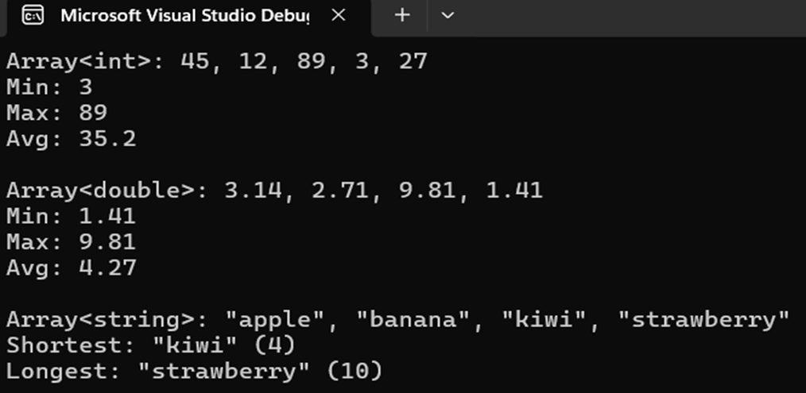

PART C: CLASS TEMPLATES
Generic container design, dynamic memory management, non-type template parameters, and generic exceptions
Problem 3.1: Generic Safe Dynamic Array Container (Custom Vector)
Problem Description: Construct a custom generic container class 'SafeArray<T>' that models the fundamental behaviors of dynamic arrays without relying on std::vector. The class must manage dynamic heap allocations safely, resize automatically when capacity is reached, and implement defensive bounds verification.
Functional & Technical Requirements:
• Class Template: template <typename T> class SafeArray.
• Private members: T* data, size_t capacity.
• Constructors: Default constructor (initial capacity = 4), parameterized constructor with initial size, copy constructor and assignment operator for deep copying (Rule of Three), destructor releasing memory.
• Methods: void push_back(const T& element), void pop_back(), size_t size(), size_t getCapacity().
• Operator Overloading: Overload subscript operator 'T& operator[](int index)' with out-of-bounds index boundary checking that throws an std::out_of_range exception.
• Test instantiation with: SafeArray<int>, SafeArray<std::string>, and a custom user-defined class 'Product' (id,name, price).
CODE:
1)Product.h File
#ifndef PRODUCT_H
#define PRODUCT_H

#include <iostream>
#include <string>

using namespace std;

class Product
{
private:
int id;
string name;
double price;

public:

Product()
{
id = 0;
name = "";
price = 0.0;
}

Product(
int id,
string name,
double price)
{
this->id = id;
this->name = name;
this->price = price;
}

void display() const
{
cout << "[ID: " << id
<< ", Name: " << name
<< ", Price: $"
<< price
<< "]";
}
};

#endif

2) SafeArray.h File:
#ifndef SAFEARRAY_H
#define SAFEARRAY_H

#include <iostream>
#include <stdexcept>
#include <string>

using namespace std;

template <typename T>
class SafeArray
{
private:

// Pointer to dynamically allocated array
T* data;

// Total available memory
size_t capacity;

// Number of elements currently stored
size_t currentSize;

// =============================================
// Private resize function
// =============================================

void resize()
{
size_t oldCapacity = capacity;

capacity = capacity * 2;

T* newData =
new T[capacity];

// Copy old elements
for (size_t i = 0;
i < currentSize;
i++)
{
newData[i] = data[i];
}

// Delete old array
delete[] data;

// Point to new array
data = newData;

cout << "Dynamic resize triggered: Capacity "
<< oldCapacity
<< " -> "
<< capacity
<< endl;
}

public:

// =============================================
// Default constructor
// =============================================

SafeArray()
{
capacity = 4;
currentSize = 0;

data = new T[capacity];
}

// =============================================
// Parameterized constructor
// =============================================

SafeArray(size_t initialCapacity)
{
if (initialCapacity == 0)
{
initialCapacity = 4;
}

capacity = initialCapacity;

currentSize = 0;

data = new T[capacity];
}

// =============================================
// Copy constructor
// =============================================

SafeArray(const SafeArray& other)
{
capacity = other.capacity;

currentSize = other.currentSize;

data = new T[capacity];

for (size_t i = 0;
i < currentSize;
i++)
{
data[i] = other.data[i];
}
}

// =============================================
// Assignment operator
// =============================================

SafeArray& operator=(
const SafeArray& other)
{
// Self-assignment check
if (this != &other)
{
T* newData =
new T[other.capacity];

for (size_t i = 0;
i < other.currentSize;
i++)
{
newData[i] =
other.data[i];
}

delete[] data;

data = newData;

capacity = other.capacity;

currentSize =
other.currentSize;
}

return *this;
}

// =============================================
// Destructor
// =============================================

~SafeArray()
{
delete[] data;
}

// =============================================
// push_back()
// =============================================

void push_back(const T& element)
{
// If array is full
if (currentSize == capacity)
{
resize();
}

data[currentSize] =
element;

currentSize++;
}

// =============================================
// pop_back()
// =============================================

void pop_back()
{
if (currentSize == 0)
{
throw out_of_range(
"Cannot pop from empty array!"
);
}

currentSize--;
}

// =============================================
// size()
// =============================================

size_t size() const
{
return currentSize;
}

// =============================================
// getCapacity()
// =============================================

size_t getCapacity() const
{
return capacity;
}

// =============================================
// operator[]
// =============================================

T& operator[](int index)
{
if (index < 0 ||
index >=
static_cast<int>(currentSize))
{
throw out_of_range(
"Index " +
to_string(index) +
" out of bounds!"
);
}

return data[index];
}

// =============================================
// const operator[]
// =============================================

const T& operator[](int index) const
{
if (index < 0 ||
index >=
static_cast<int>(currentSize))
{
throw out_of_range(
"Index " +
to_string(index) +
" out of bounds!"
);
}

return data[index];
}
};

#endif

3)Main cpp file:
#include <iostream>
#include <string>

#include "SafeArray.h"
#include "Product.h"

using namespace std;

int main()
{
// =============================================
// SafeArray<int>
// =============================================

cout << "===== SafeArray<int> ====="
<< endl;

SafeArray<int> arr1;

arr1.push_back(10);
arr1.push_back(20);
arr1.push_back(30);
arr1.push_back(40);

cout << "Size: "
<< arr1.size()
<< endl;

cout << "Capacity: "
<< arr1.getCapacity()
<< endl;

// This causes resize: 4 -> 8
arr1.push_back(50);

cout << "Element at index 2: "
<< arr1[2]
<< endl;

// =============================================
// SafeArray<string>
// =============================================

cout << "\n===== SafeArray<string> ====="
<< endl;

SafeArray<string> arr2;

arr2.push_back("C++");
arr2.push_back("Java");
arr2.push_back("Python");

cout << "Element at index 1: "
<< arr2[1]
<< endl;

// =============================================
// SafeArray<Product>
// =============================================

cout << "\n===== SafeArray<Product> ====="
<< endl;

SafeArray<Product> products;

cout << "SafeArray<Product> Initialized."
<< endl;

products.push_back(
Product(
101,
"Mobile",
499.99
)
);

products.push_back(
Product(
102,
"Tablet",
699.99
)
);

products.push_back(
Product(
103,
"Laptop",
899.99
)
);

products.push_back(
Product(
104,
"Monitor",
299.99
)
);

// Fifth item causes
// capacity 4 -> 8

products.push_back(
Product(
105,
"Keyboard",
49.99
)
);

cout << "Pushed "
<< products.size()
<< " items."
<< endl;

// =============================================
// Access index 2
// =============================================

cout << "\nElement at index 2: ";

products[2].display();

cout << endl;

// =============================================
// Exception handling
// =============================================

try
{
cout << "\nAttempting access at index 10..."
<< endl;

products[10].display();
}
catch (const out_of_range& e)
{
cout << "Exception Caught: "
<< e.what()
<< endl;
}

// =============================================
// pop_back()
// =============================================

products.pop_back();

cout << "\nAfter pop_back(), size = "
<< products.size()
<< endl;

// =============================================
// Copy constructor
// =============================================

SafeArray<Product> copyProducts =
products;

cout << "\nCopy constructor called."
<< endl;

cout << "Copied array size: "
<< copyProducts.size()
<< endl;

// =============================================
// Assignment operator
// =============================================

SafeArray<Product> anotherProducts;

anotherProducts = products;

cout << "Assignment operator called."
<< endl;

cout << "Assigned array size: "
<< anotherProducts.size()
<< endl;

return 0;
}
OUTPUT:


